Project Report

and

User Manual

Team 8 - eBook Perpetual Access Tracking

CS-4820 Software System Project

Submitted by:

Beakal Begashaw

Cian Bottomley-Mason

Dilraj Singh Gill

Ethan Penney

Isaac Wolters

Jasleen Kaur

Table of Contents

Abstract

1. **Introduction**

1.1 Project aim and objectives

1.2 Background of the project

1.3 Operation environment

1. **System Analysis**

2.1 Software Requirement Specifications

2.2 Existing v/s Proposed

2.3 Software Tools used

1. **System Design**

3.1 Table Design

3.2 Data Flow Diagrams

3.3 Sequence diagram

1. **System Implementation**

4.1 Module description

4.2 Screenshots

1. **System Testing**
2. **End User Documentation**
3. **Conclusion**

**ABSTRACT**

The ebook perpetual access tracking application will assist librarians with the tracking of perpetual access rights for ebooks available for their library or institution. Libraries have a collection of ebooks from various publishers that they purchase the perpetual access rights to. Librarians track these access rights, as occasionally, access rights may be incorrectly revoked by the publishers or simply to keep a log of all of the ebooks they have access to. However, there is no standardized way to do this. The Canadian Research Knowledge Network (CRKN) maintains a collection of spreadsheets that contain the ebooks that all Canadian institutions have access to from those publishers. Individual institutions can also purchase ebooks, so they also maintain their own collection of spreadsheets. As a result, searching for a particular ebook access rights is inconvenient and takes place across a number of spreadsheets in various locations. The ebook perpetual access tracking application will provide a centralized location for librarians to verify whether or not they have the rights to access a particular ebook or collection of ebooks at their particular library or institution.

**1. INTRODUCTION**

This chapter gives an overview of the aim and objectives of the project along with the system's background and operation environment.

1.1 Project aim and objectives

The aims and objectives that will be achieved after the completion of this project are as follows:

* Develop a centralized application for librarians to track ebook perpetual access rights, eliminating the inconvenience of searching across multiple spreadsheets.
* Facilitate the loading of both CRKN access spreadsheets and local institution spreadsheets into a local database, ensuring seamless data integration.
* Implement a robust search system allowing users to search ebooks by title, ISBN, or OCN numbers.
* Develop an application that is accessible

1.2 Background of the Project

Traditionally, librarians have relied on manual methods to access and track perpetual access rights for ebooks via maintaining and accessing multiple different spreadsheets. The CRKN has played a crucial role in maintaining and managing the aggregation of information about ebooks to various Canadian institutions from multiple publishers. Nonetheless, the information is spread across multiple spreadsheets which are maintained by not only the CRKN but the institutions as well, making it difficult for the librarians to keep track and verify their access rights.

The idea of this application was conceived to provide a more convenient way to track and verify these access rights for ebooks. This project aims to develop a user-friendly application for librarians to effectively track access rights available to them and their institutions.

The application will not only be able to access the spreadsheets offered by the CRKN but also allow access to the local spreadsheets available to the librarians through their institutions. This information will be centralized in a database, which the librarians can access and verify via the application's user-friendly interface. Additionally, the application will allow the librarians to search ebooks by their title, OCN, ISBN or any combination of the three.

1.3 Operation Environment

The eBook Perpetual Access Rights Tracker is a Python application with versions that operate across the three main operating systems. The following is a list of dependencies and libraries used during the creation of the application, also found in the requirements.txt file in the GitHub project repository.

beautifulsoup4==4.12.3

pandas==2.2.0

Requests==2.31.0

openpyxl==3.2.0b1

PyQt6==6.6.1

pytest==8.0.0

1. **System Analysis**

2.1.1 Software Requirement Specifications

Product Description:

The application ePAT is a desktop application that helps the users (librarians) manage and keep records of perpetual access rights for eBooks in the library in the form of tables in a local database. It helps users to not only access these perpetual access rights once the database is updated from the CRKN website, but it also allows the users to upload their local files into the database.

PROBLEM STATEMENT: The problems that occurred before having the application include:

* Accessing the ebook data files:

Before the application, the users (librarians) had to go through the ebook data files they had in their system to search for the ebook they wanted to look up for tracing perpetual access rights about it via using its title or OCN or ISBN.

* Difficult to search records:

Before the application, the users (librarians) had to go through every ebook data file to search for their desired results.

* Time-consuming and difficult:

Before the application, the search process for ebook perpetual access rights in the ebook data files was very time-consuming and cumbersome. Also, since the records are enormous, looking through all of them turned out to be very difficult.

* Lost records/ebook data files:

Before the application, ebook data files could get misplaced or be lost forever, leaving no records of them, making it quite challenging to check for previous updates and records when needed.

2.1.2 System Objectives

* Improvement in ease of accessing files by providing all of them via one platform (database setup in the application):

The system has a database which holds all the data from the ebook data files in a sorted table format providing a much easier way of searching and accessing ebook access rights via searching for their title or OCN or ISBN.

* Ease of updating the database:

The application provides the users (librarians) with an option to stay updated by asking them to update their database, which then updates the database with all the recent and new information.

The application also allows the users (librarians) to upload any local files they might have on their system into the database.

* Ease and efficiency of searching ebooks:

The application allows the users (librarians) to search for ebooks using their title, OCN or ISBN across all files in the database at once.

* Track record of previous files:

The application keeps a copy of previous updates and data in the database, and if required, these records can be accessed easily, without the fear of them being lost or misplaced forever.

2.1.3 System Requirements

2.1.3.1 Non-functional requirements:

Product Requirements:

* Efficiency Requirement: When the ePAT application is implemented, librarians and users will be easily able to access perpetual access rights for ebooks very quickly.
* Reliability Requirements: The system should accurately and efficiently perform searches based on ebook title, OCN and ISBN, returning a list of matching eBooks with their corresponding access rights and attributes.
* Usability Requirements: The application is designed to provide a user-friendly interface so that librarians can easily and efficiently perform searches.
* Implementation Requirements: In implementing the whole application, PyQt in Python has been used to develop the GUI. For the database, SQLite3 has been used which comes bundled with Python modules for creating databases. All the backend and frontend connectivity has been done using Python itself.

2.1.3.1 Functional requirements:

1.1 SEARCH EBOOK:

Description of feature: We can search an ebook via its Title, OCN or ISBN.

Functional requirements:

* The application should be able to collect the CRKN eBook data files and store them in the database, or update the existing files if new versions exist.
* The application should be able to search the database based on the type of search.
* The application should be able to filter out data based on the type of boolean option selected.
* The application should be able to display the filtered results in a table format.

1.2 UPLOAD LOCAL FILES:

Description of the feature: We can upload local files (files that are already present in our system) to the database.

Functional requirements:

* The application should allow the user to upload a file from their system into the database.
* The database should store the ebook data file and allow access to it via performing the search.

1.3 CHANGE INSTITUTION:

Description of the feature: We can select the institution for which we want to search the PA rights of eBooks.

Functional requirements:

* The application should allow the user to change institutions in the Settings section of the application.
* The application should save the user’s preference for any future searches, as well as for the next time the application starts.

1.4 UPDATE LOCAL DATABASE:

Description of the feature: The application allows users to update their local database for any recent changes/additions.

Functional requirements:

* The application should allow the user to choose whether to update (re-scrape the CRKN website) for any changes at the launch of the application.
* Allow the user to go to the Settings section of the application and be able to update the database per need.

1.5 EXPORT SEARCH RESULTS:

Description of the feature: The application allows the user to download their search results into their system.

Functional requirements:

* The application should be able to display the relevant results in a tabular format.
* The application should have an export/download button at the bottom of the results table.
* The application should be able to ask for the location where the user wants the results stored in the form of a .tsv file.

1.6 SCRAPES PERPETUAL ACCESS RIGHT DATA:

Description of the feature: The application allows users to scrape the CRKN website for any recent updates and update the local database accordingly.

Functional requirements:

* The application should allow the user with a selection to scrape the CRKN website in the form of a pop-up right when the application launches.
* Allow the user to select and proceed further with the application or search process.
* Allow the pop-up to be displayed every time the user launches the application.

2.1.4 Software and Hardware Requirements:

This section describes the system's software and hardware requirements.

2.1.4.1 Software requirements:

* Operating System: Windows 10 and 11, macOS, and Linux (Ubuntu) as it is stable, supports more features, and is user-friendly.
* Python 3.10-3.12 versions were used throughout the development of the application.

2.1.4.2 Hardware requirements:

* Intel core i5 for Windows and M1 processor for Mac have been used because they are faster than the other processors and provide a reliable and stable environment in which to run the code for a longer time on our systems.

2.2.1 Existing System

* Earlier, librarians used to search for PA rights for eBooks in multiple spreadsheets stored and saved in their system.
* They had to update and replace these spreadsheets manually from the CRKN website and keep a regular check for updates.
* Maintain and arrange these ebook data files manually.
* Look for PA rights for an eBook via its title, OCN or ISBN, making the task complex and time-consuming.
* Loss of old records led to difficulty in searching if the institution had rights to a particular eBook or not.

2.2.2 Proposed System

“ePAT-” The eBook Perpetual Access Rights Tracking app has been developed to solve the inconveniences mentioned in the existing system.

* Users can select their institution.
* Users can select their language.
* Set up a database with all the ebook data files from the CRKN website.
* The app offers to check the CRKN website for any updates and gives librarians a choice of whether to update or not.
* Allows librarians to upload their own ebook data files to the database.
* Allow the user to perform searches for ebooks via their title, OCN, and ISBN.
* Allow the user to export their search results in the form of a TSV file.

2.3 Software Tools Used

The whole project is divided into two parts: Frontend (GUI) and Backend.

2.3.1 Front end:

* The front end is designed using PyQt6 and Qt Designer.
* PyQt6 contains several Python extension modules and plugins that enable Qt Designer to extend using Python code.

2.3.2 Back end:

* The back end is designed using:
* Pandas in Python
* BeautifulSoup in Python
* SQLite3

1. **System Design**

3.1 TABLE DESIGN

eBook Data File Format

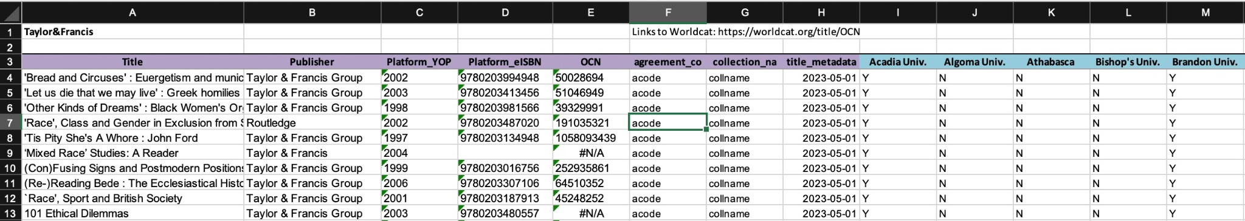

(An example of a valid eBook data file)

All files that get uploaded to the application must follow strict formatting guidelines.

* File must be an Excel (.xlsx), CSV, or TSV file.
* If the file is an Excel file, the sheet name that contains the eBook data must be titled “PA-Rights”
* Platform in top left (cell A1)
* Header row on row 3
  + First 8 headers must be, in order, Title, Publisher, Platform_YOP, Platform_eISBN, OCN, agreement_code, collection_name, and title_metadata_last_modified.
  + Following the first 8 columns, any number of institution names can follow.
* Columns Title, Platform_eISBN, and any institution name columns must have complete data for each entry in the file.
* CRKN eBook files must follow a naming convention of:
  + CRKN_EBookPARightsTracking_**platform**_YYYY_MM_DD_V.(extension)
  + Platform must be a unique identifier for each CRKN eBook file
* Local eBook files do not need to follow a standard naming convention.

DATABASE STRUCTURE:

The application uses a SQLite database to store all of the data from eBook data files obtained from the CRKN website and local uploads. The data from each file is stored in its own table, and the table name and upload/update date is stored in two separate tables.

Table 1: CRKN_file_names: (file_name, file_date)

- A collection of all the tables that contain CRKN file data.

- file_name = first part of file link name on CRKN website

- file_date = date and version number of file link name on the CRKN website

Table 2: local_file_names: (file_name, file_date)

- A collection of all the tables that contain local file data uploaded by the user.

- NOTE: Does not include "local_" that is at the beginning of the actual tables

- file_name = entire file name that is uploaded (without the extension)

- file_date = the actual date that the file was uploaded to the database

Other Tables:

- All other tables are tables listed in the two tables above

- For CRKN_file_names - direct references (file_name)

- For local_file_names - "local_" + file_name

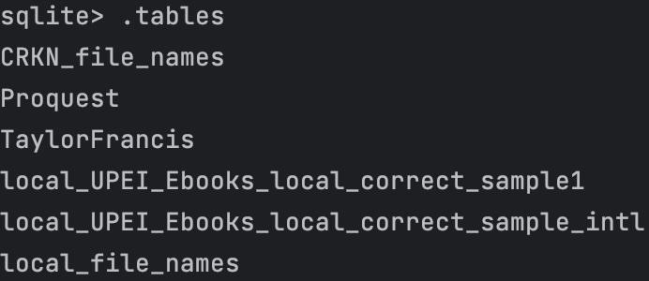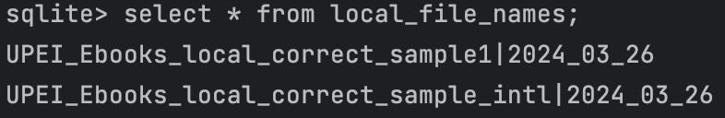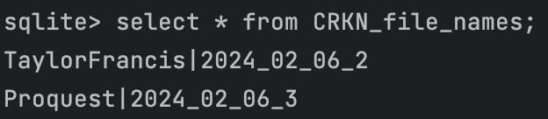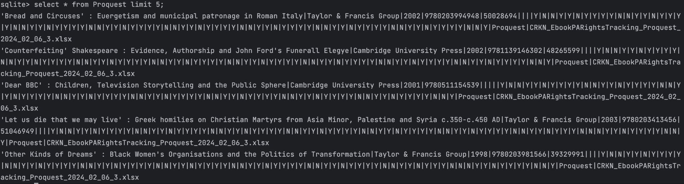

3.2 DATA FLOW DIAGRAMS

* USE CASE DIAGRAM

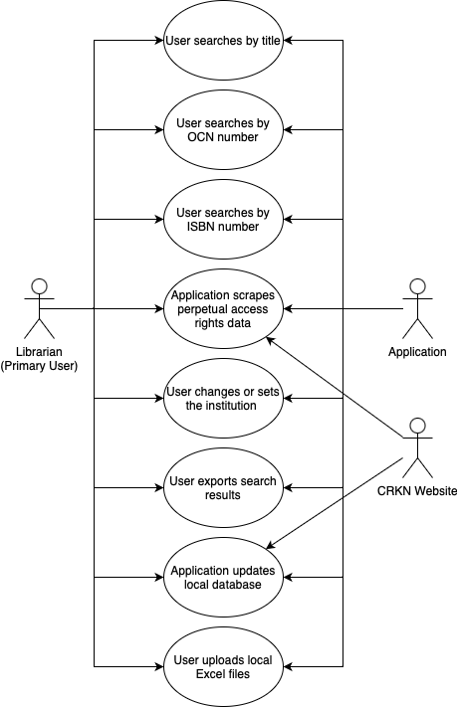

3.2 SEQUENCE DIAGRAMS

## **User changes or sets the institution**

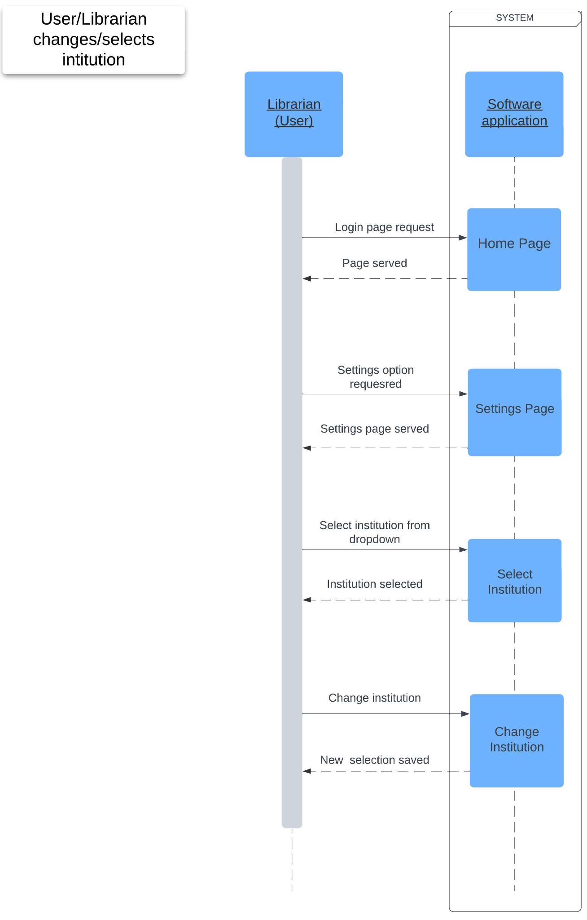

## **User searches by title (with optional partial search)**

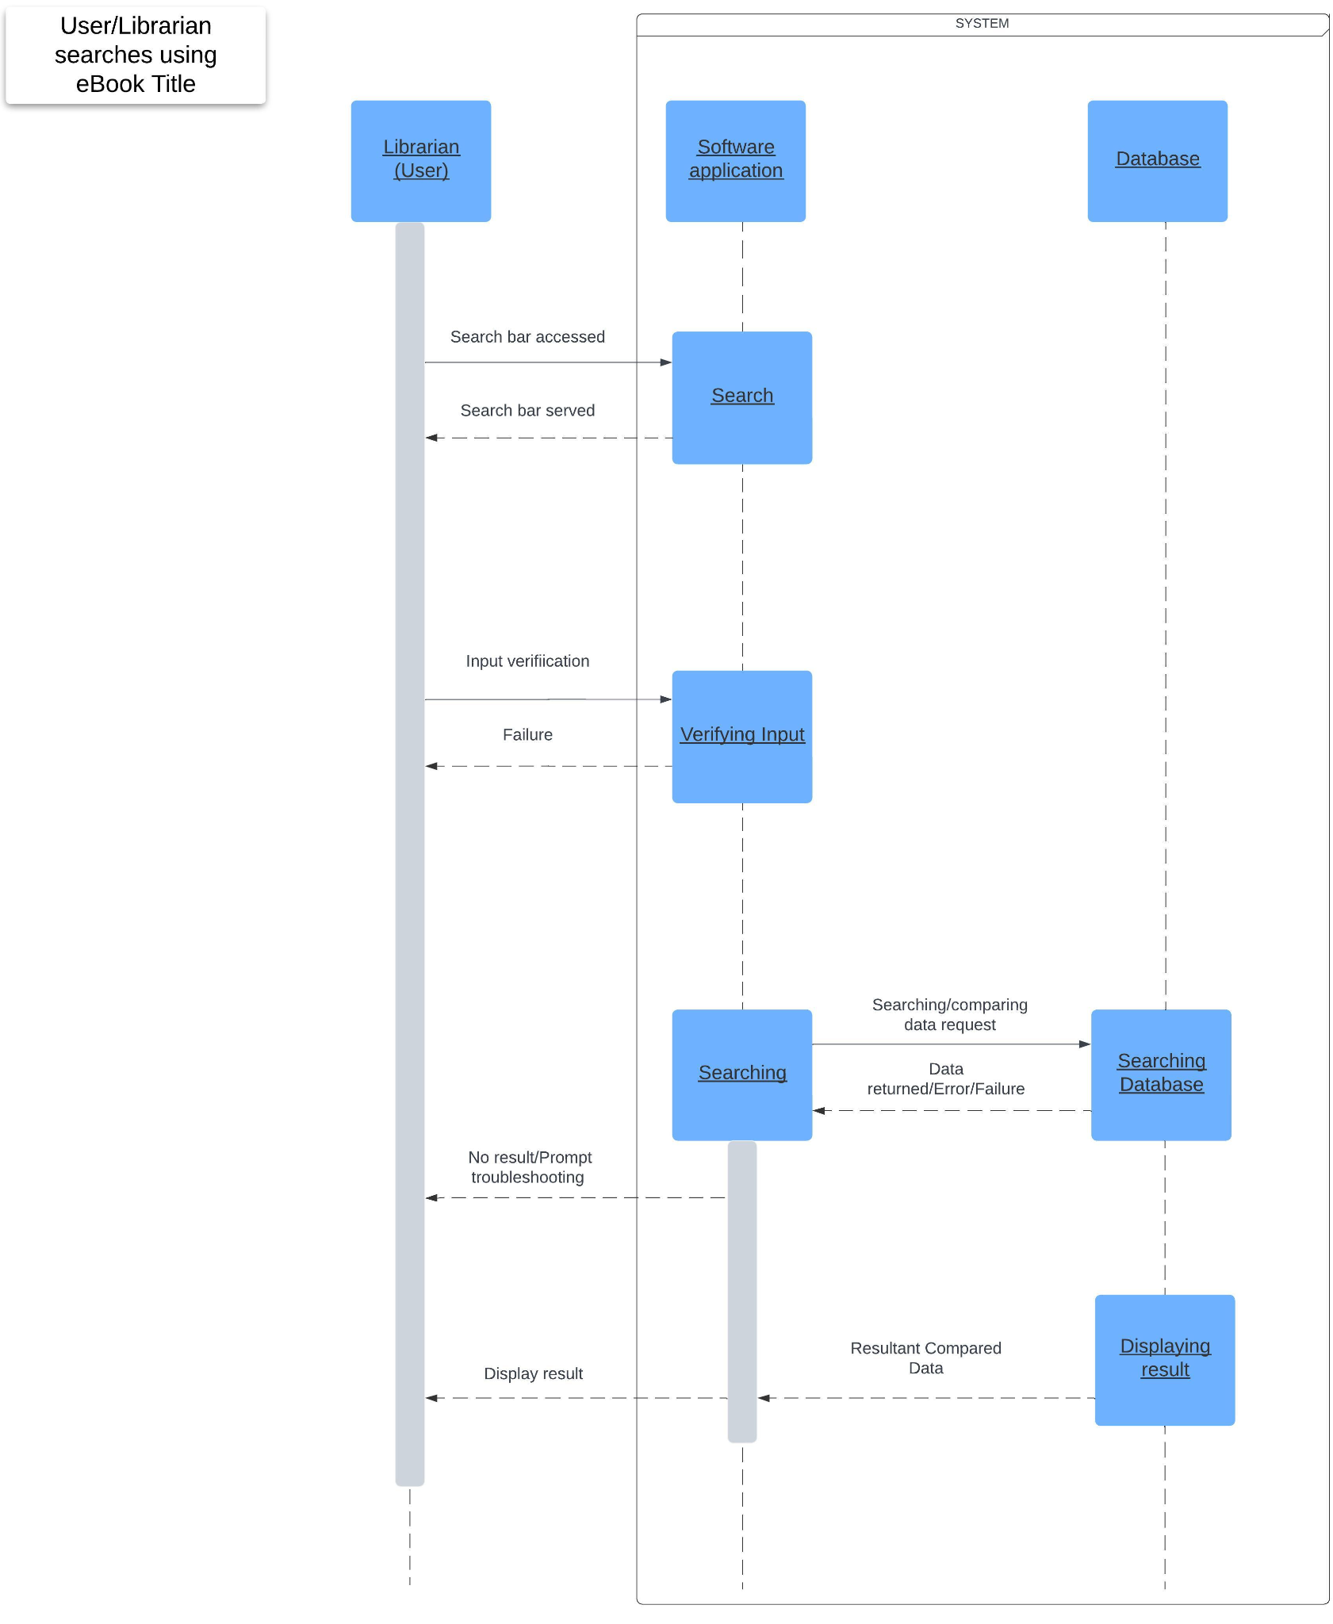

## **User searches by ISBN number**

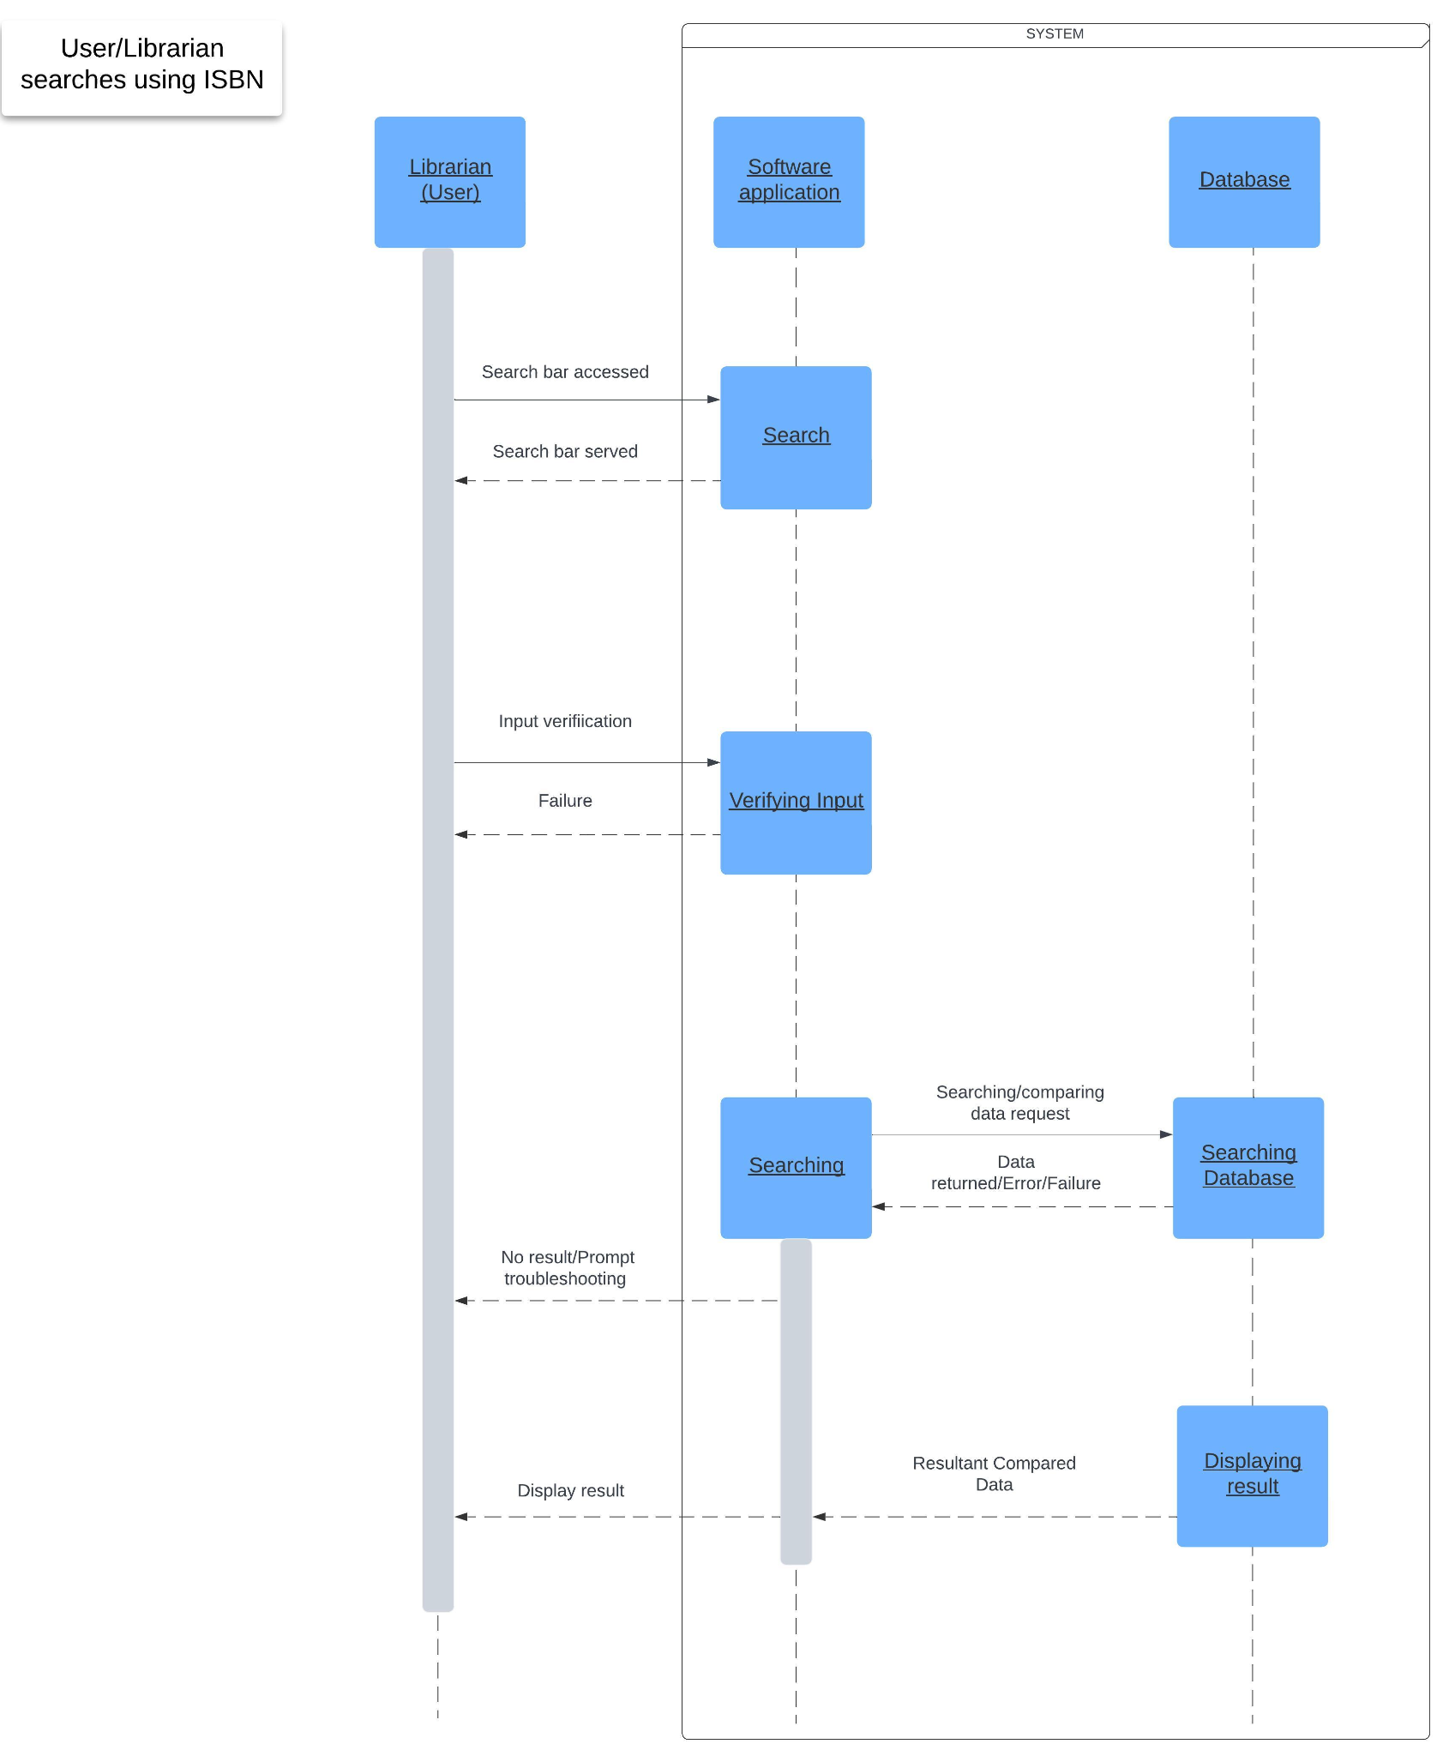

## **User searches by OCN number**

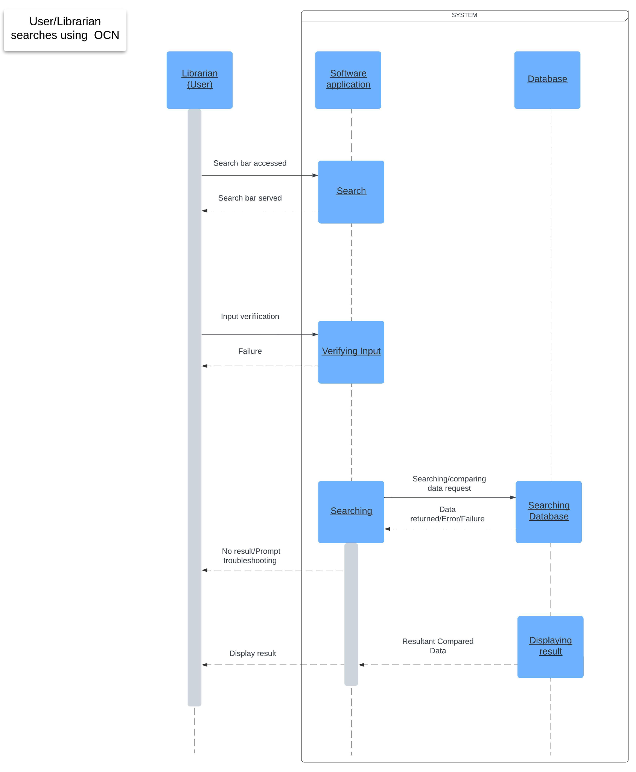

## **Application scrapes perpetual access rights data**

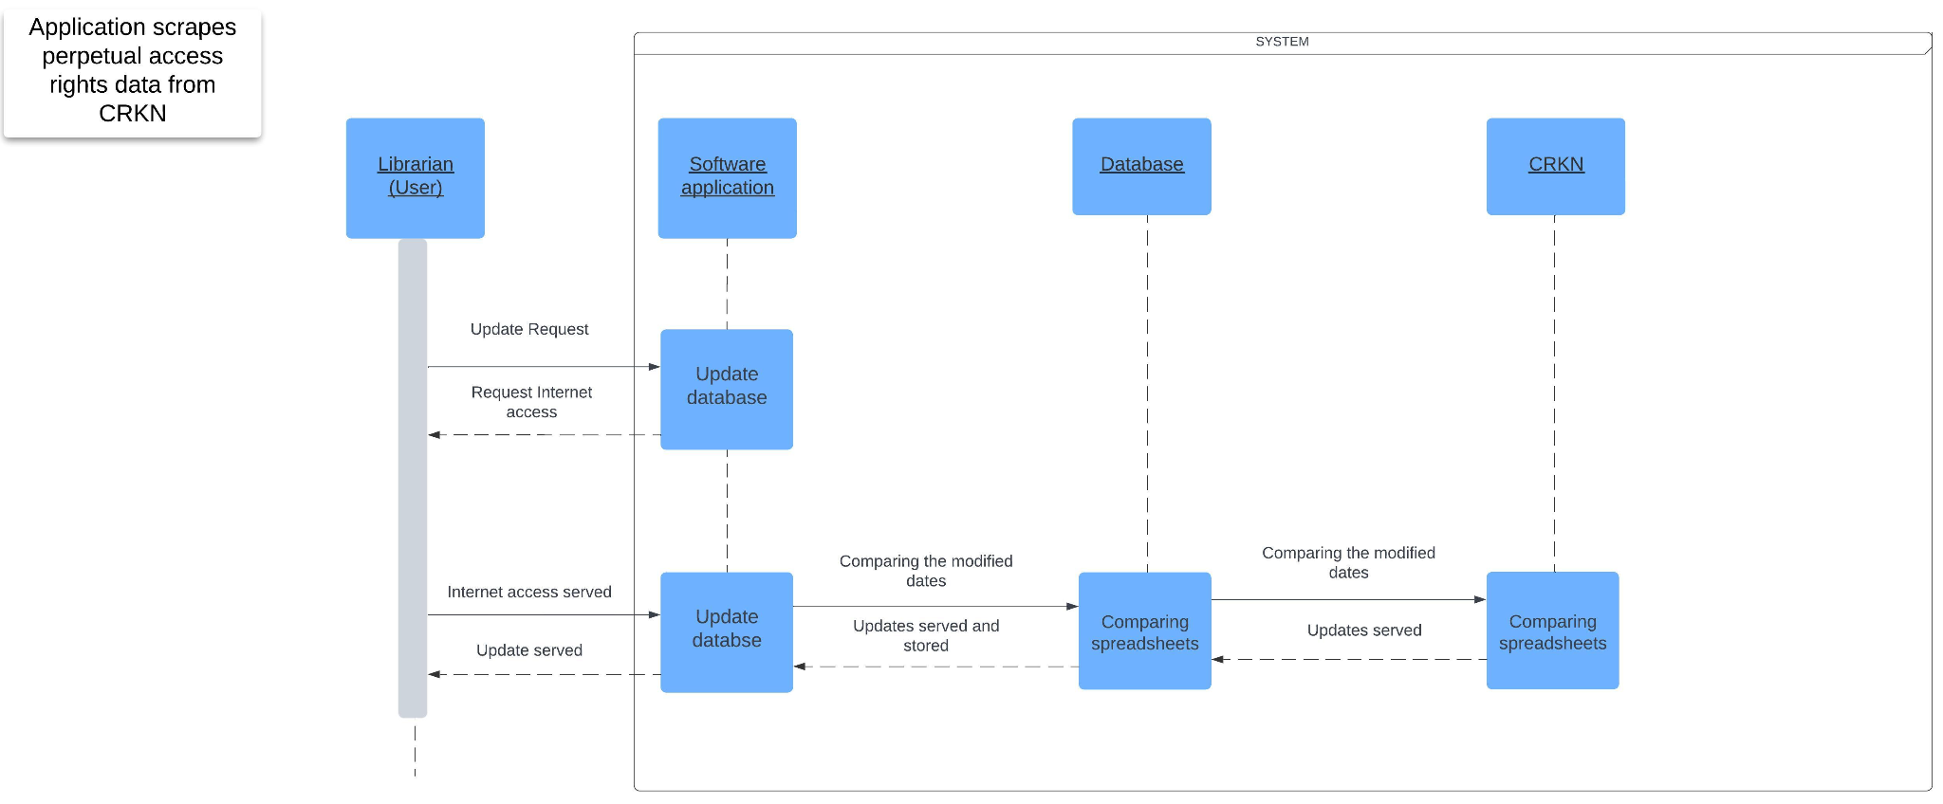

## **Application updates local database**

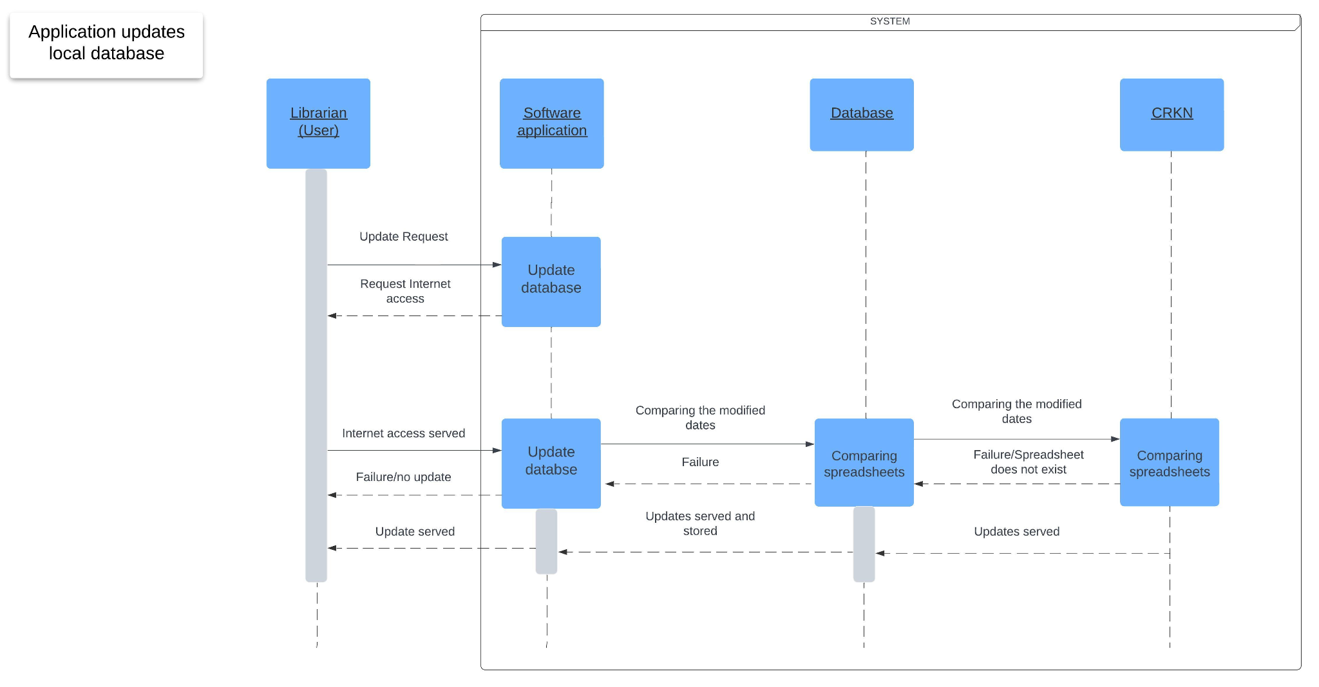

## **User exports search results**

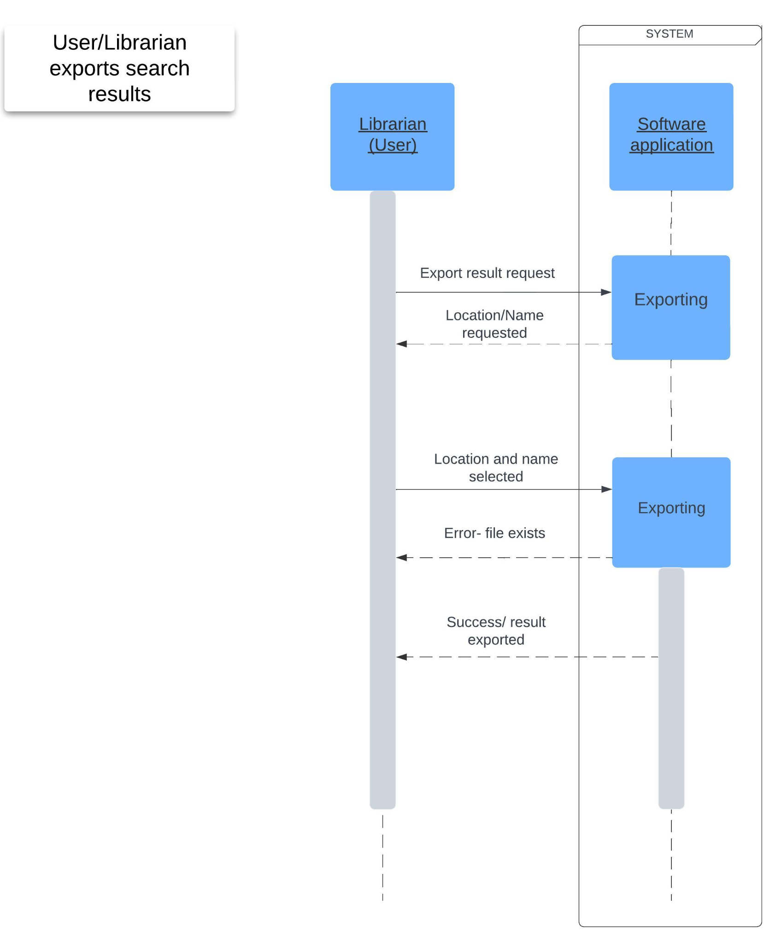

## **User uploads local ebook data files**

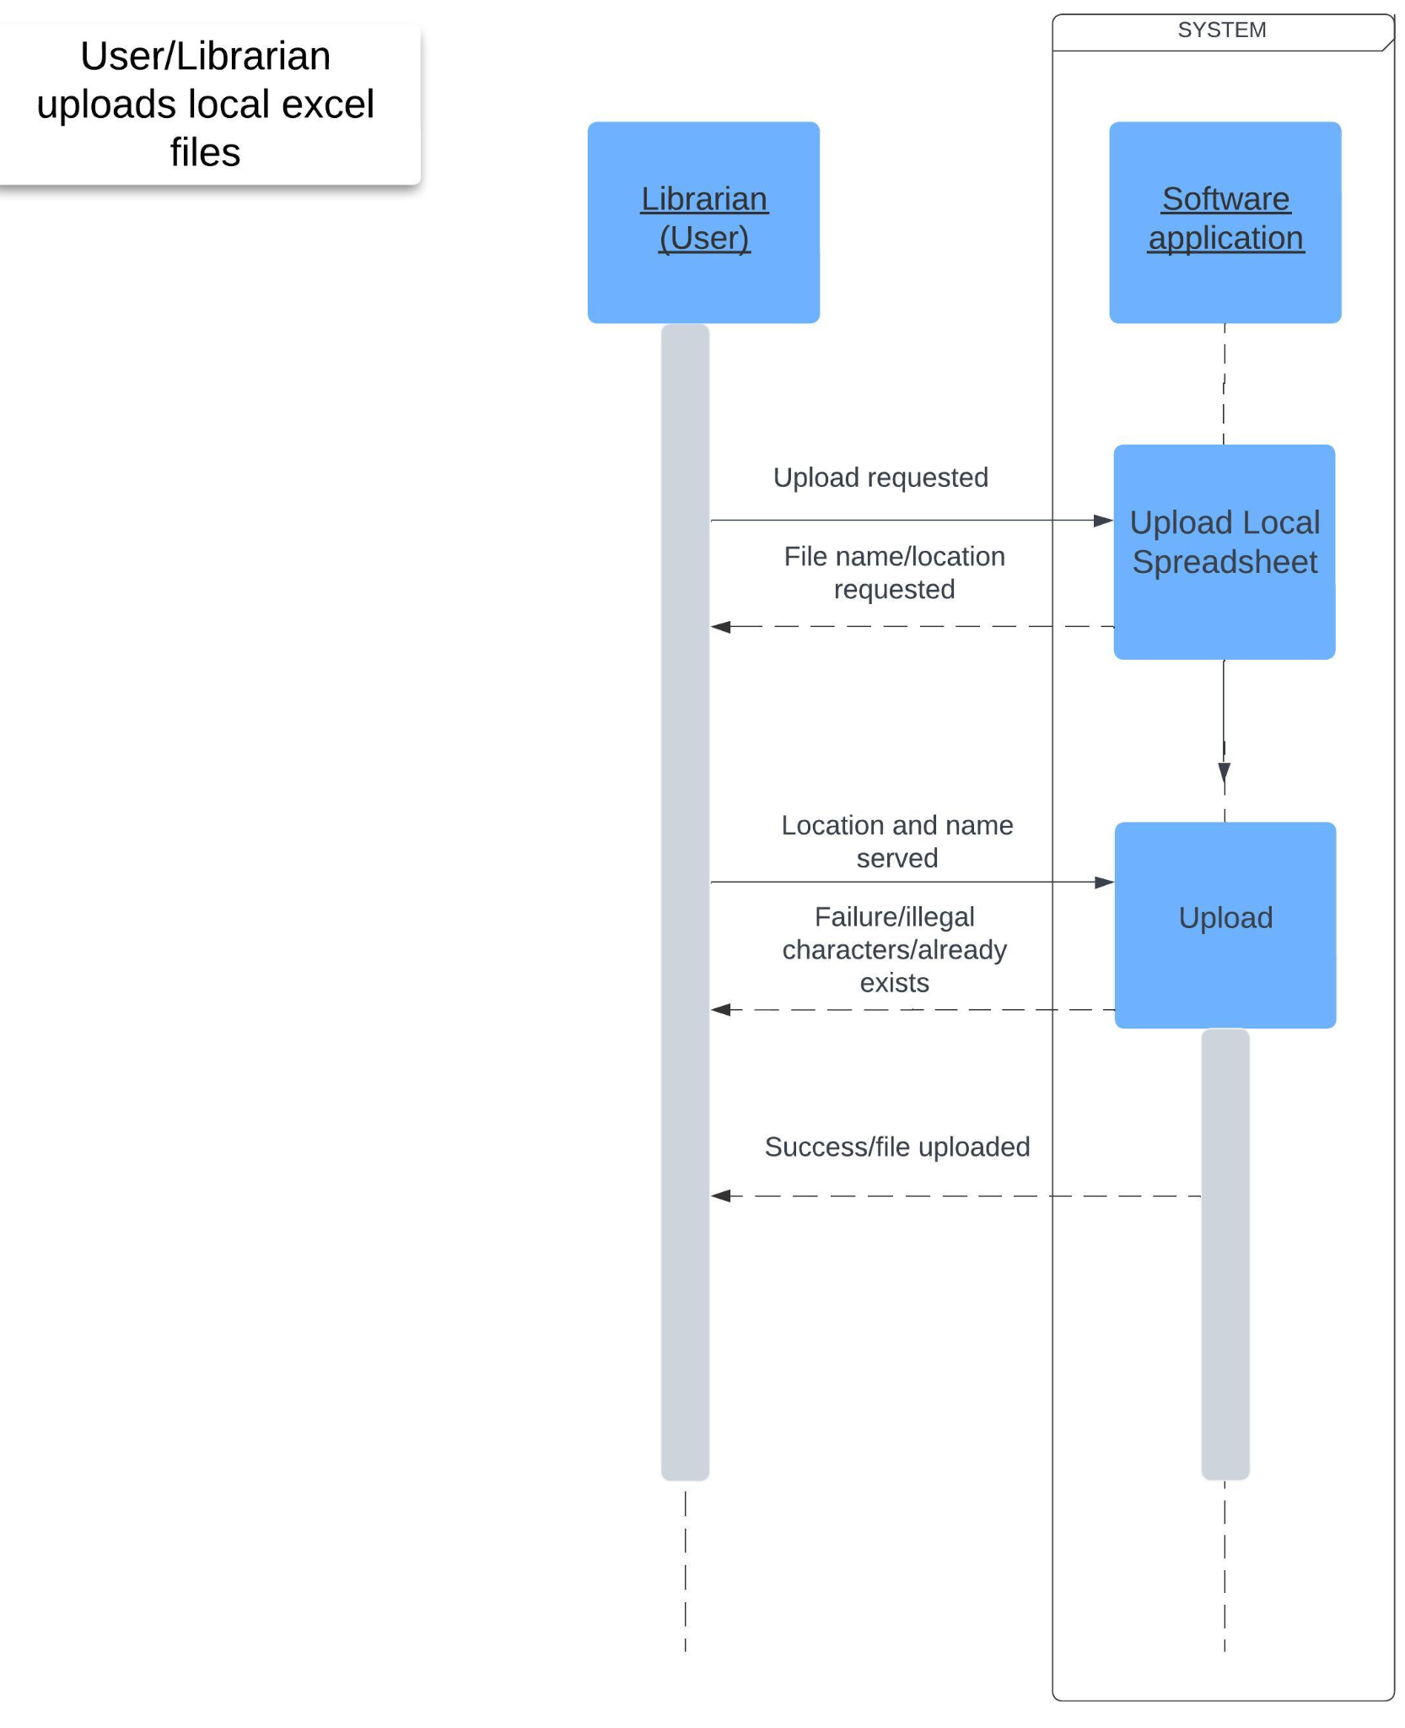

1. **System Implementation**

4.1 MODULE DESCRIPTION

The ePAT (eBook Perpetual Access Rights Tracking) application is divided into three major modules, namely:

1. The home page: This is the first page and main screen which is displayed when the application starts. It contains the primary search functionality with the logo “ePAT” at the top of the page.
2. The Settings page: This is the page linked to the main screen via the gear icon to the top left of the home page. This page helps the user manage all aspects of the application. They can select or change their institution and language. They can modify the URL for the location of the ebook data files on the CRKN website, as well as the URL for the help page on the project’s repository. They can also manage their list of local institutions and local files. Finally, in the top right corner, they can update the CRKN data, upload their own local files, and choose to turn off the CRKN functionality.
3. The Results page: This page displays the results of the user's desired search based on the ebook's title or its eISBN or OCN. The results are displayed in a tabular format, which can also be exported to the user’s computer as a TSV file. The page is connected to the main screen with a Home button to the top left of the page.

4.2 Screenshots

1. THE HOME PAGE:

The first look we get is of the Home page, which opens up with asking a question to update the CRKN eBook data files in the local database.

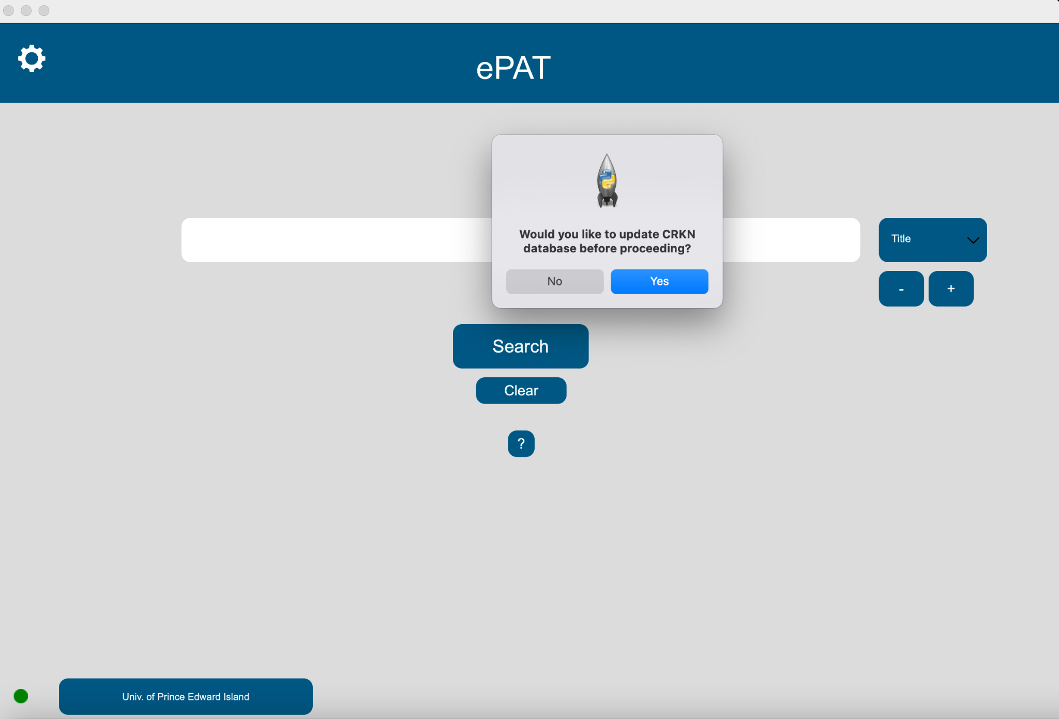

A pop-up displays the progress of the update once the ‘YES’ is selected.

The user can choose to update the local database or not.

If the user selects ‘Yes,’ the application will start retrieving data.

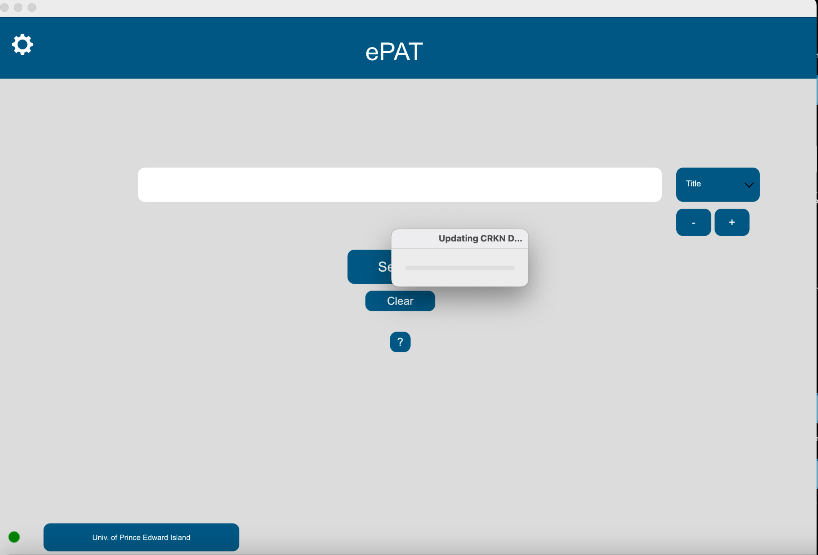

Once the update has been completed, another pop-up will appear, notifying the user of the update being completed.

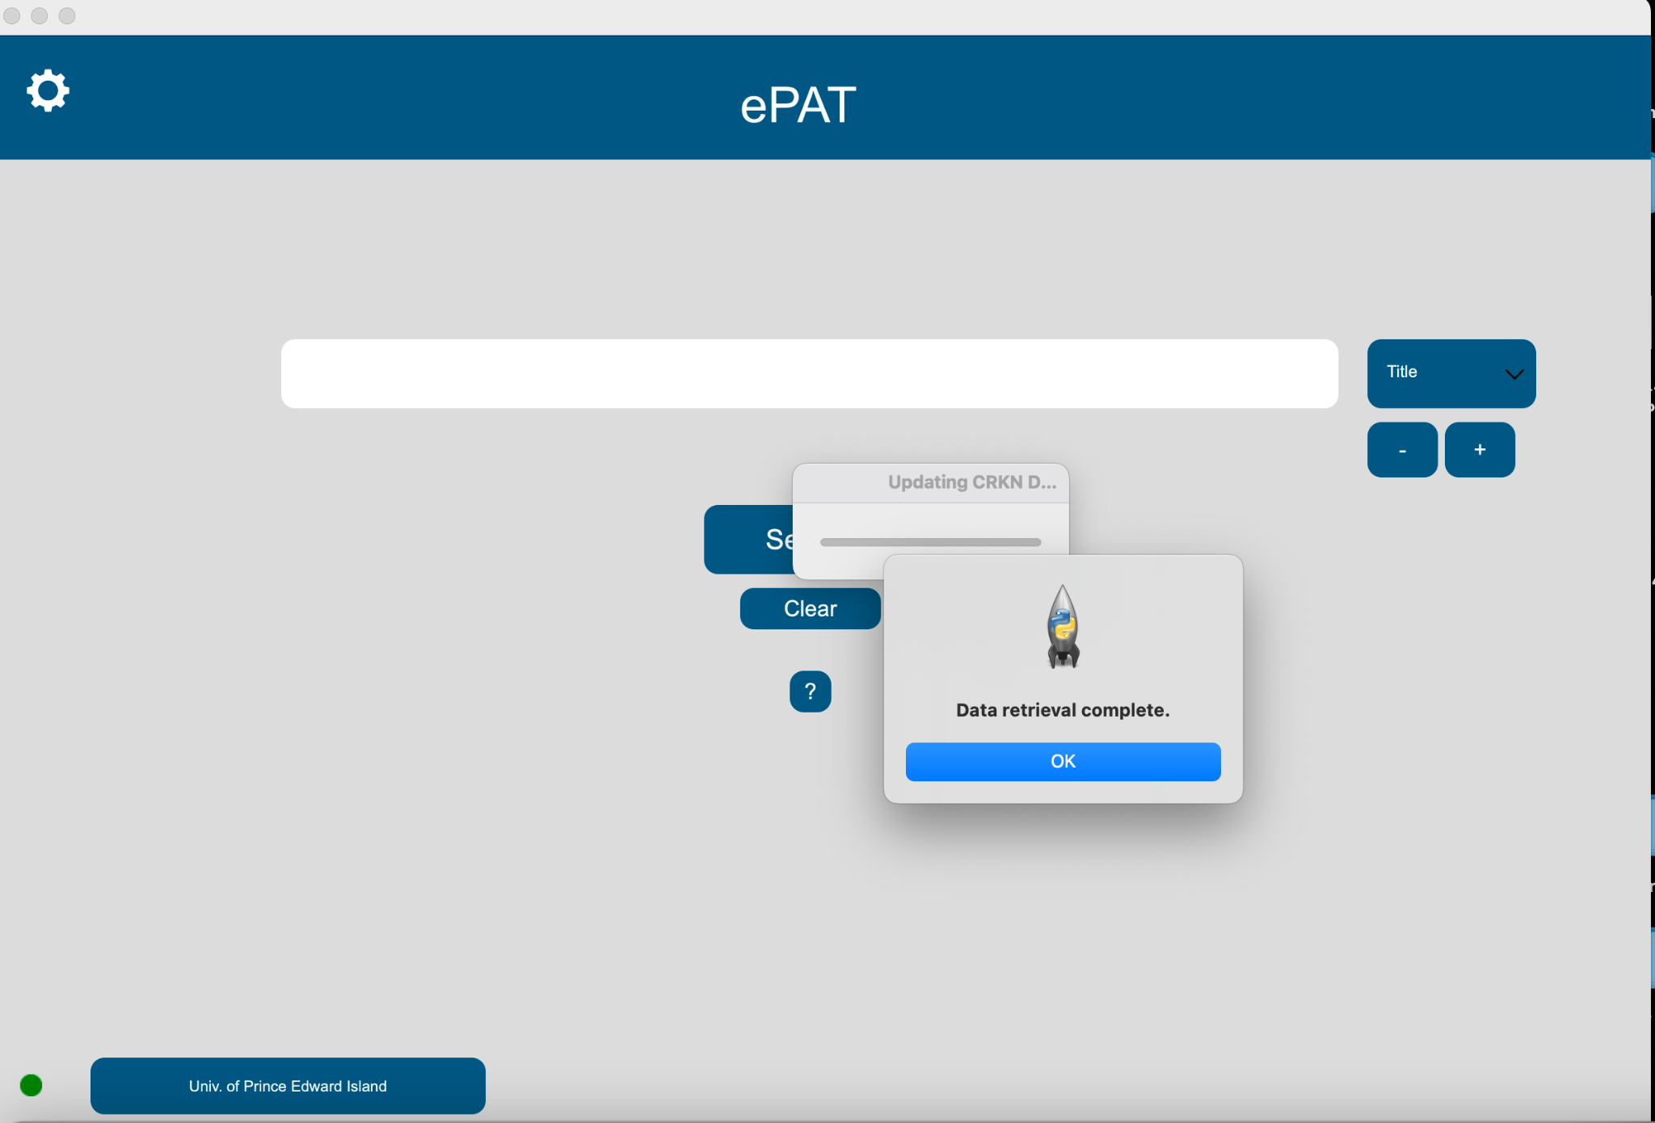

Hit the ‘OK’ to get to the main screen of the home Page.

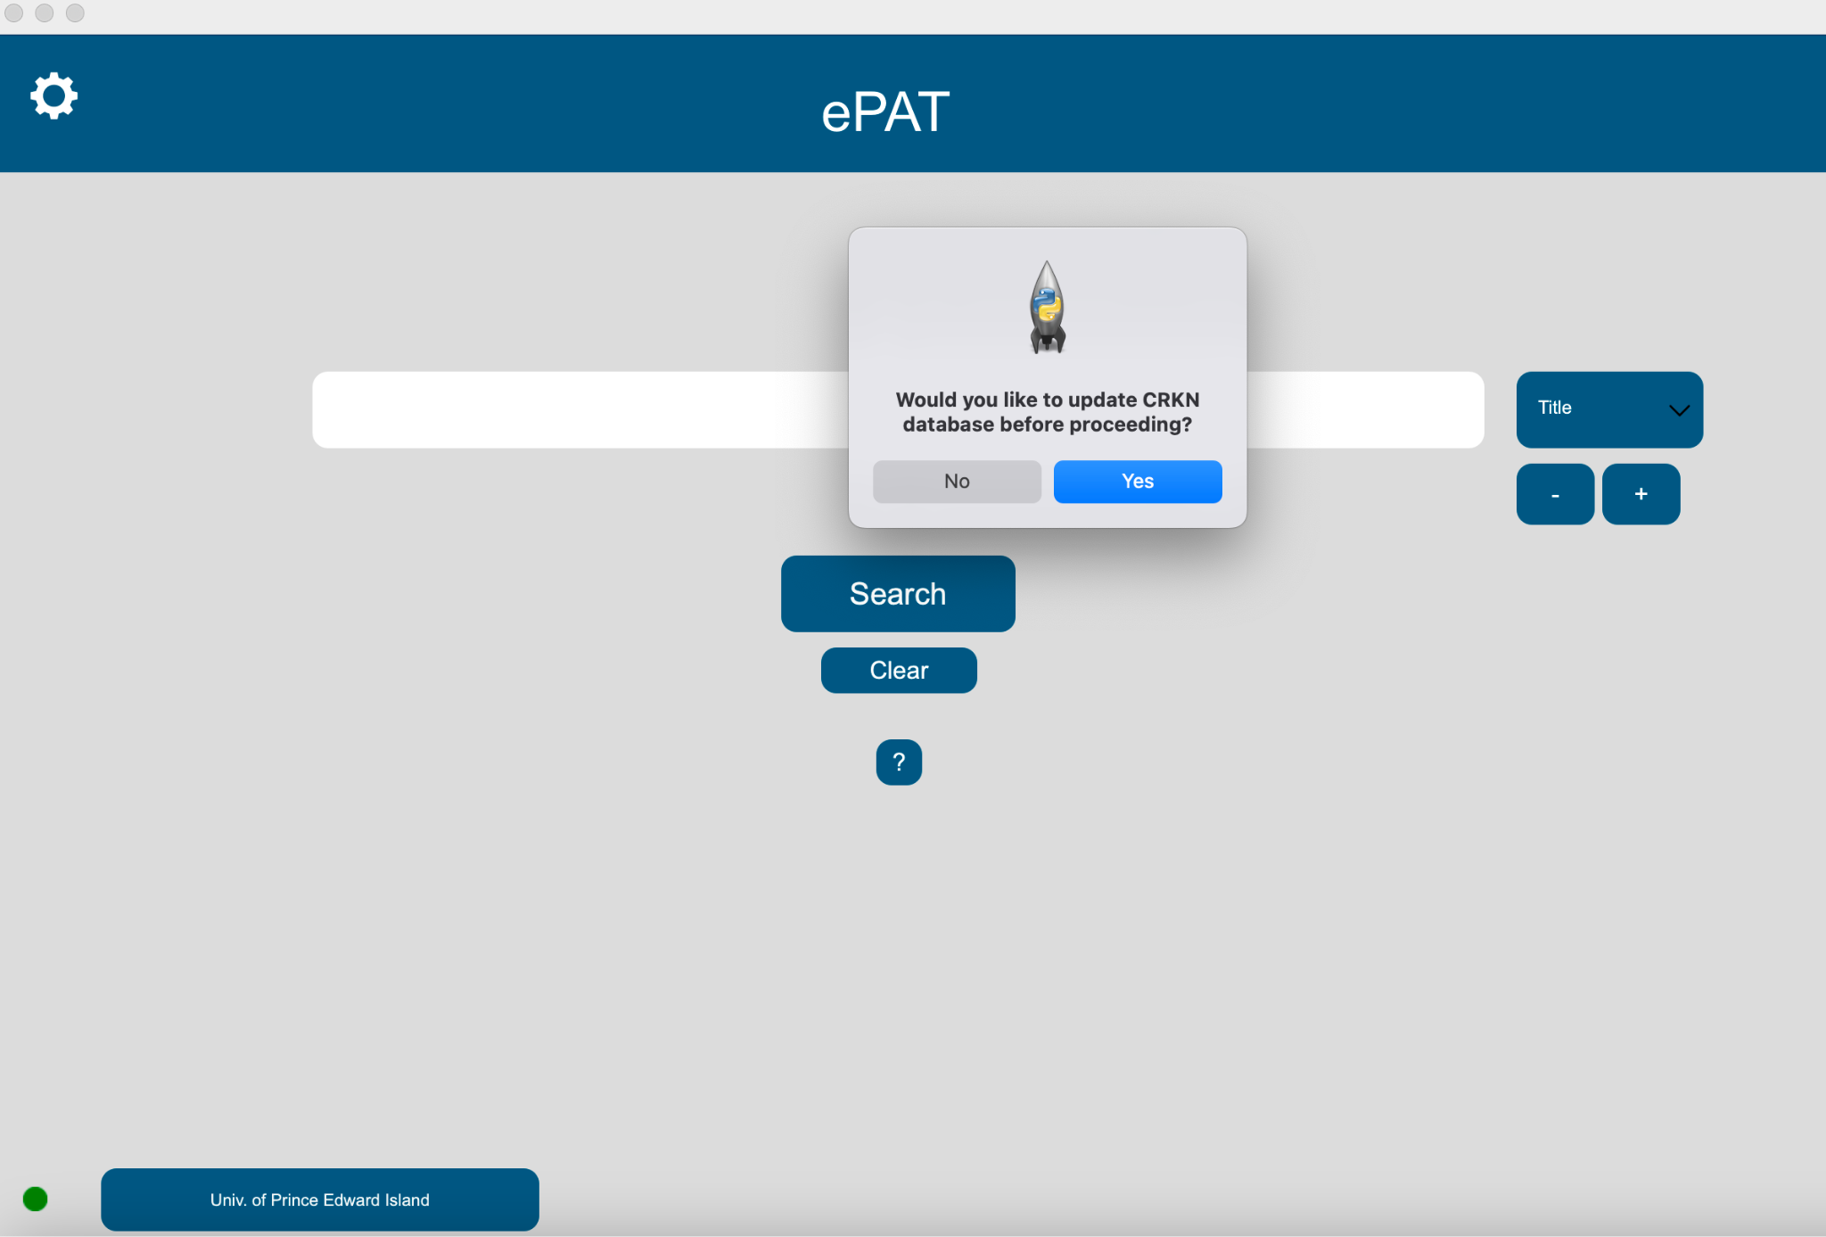

The green button on the bottom of the page notifies the user of an active internet connection. Internet connection is needed when the user would like to update the CRKN files in the database, which are retrieved from the CRKN website online.

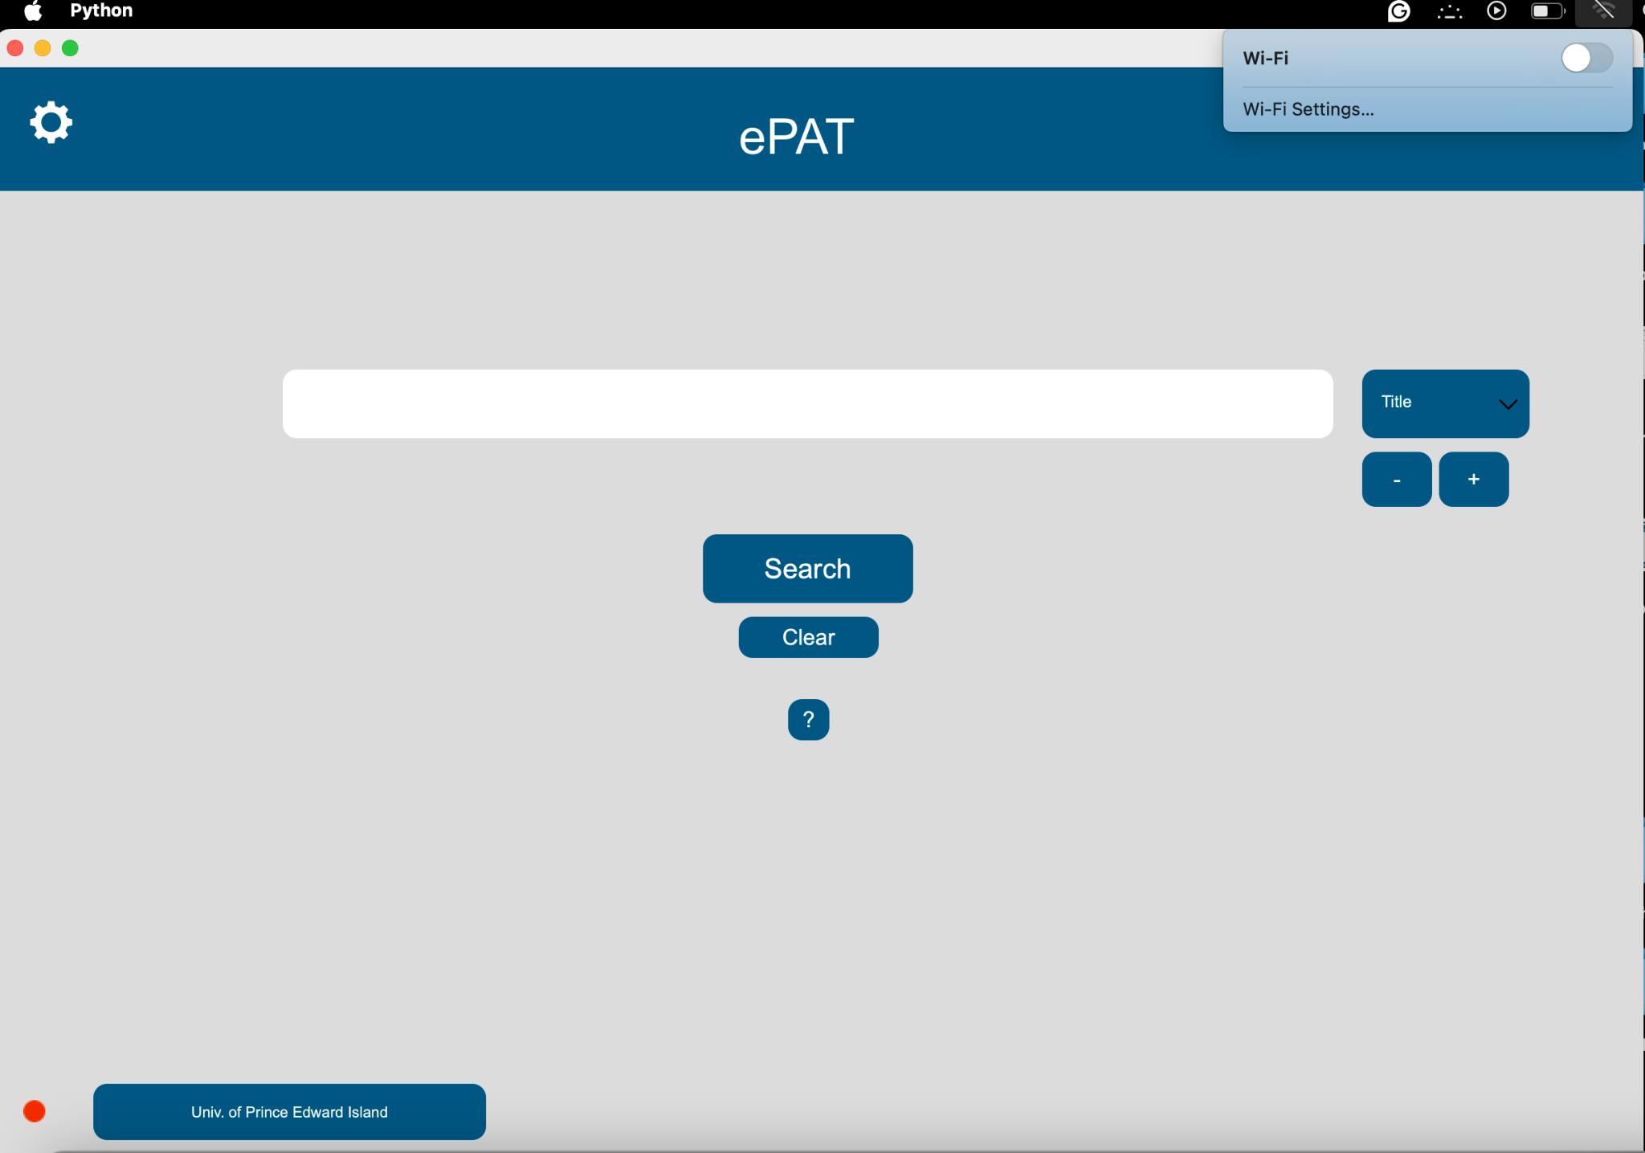

The green button turns red as soon as the internet connection is lost.

*THE SEARCH FUNCTIONALITY:*

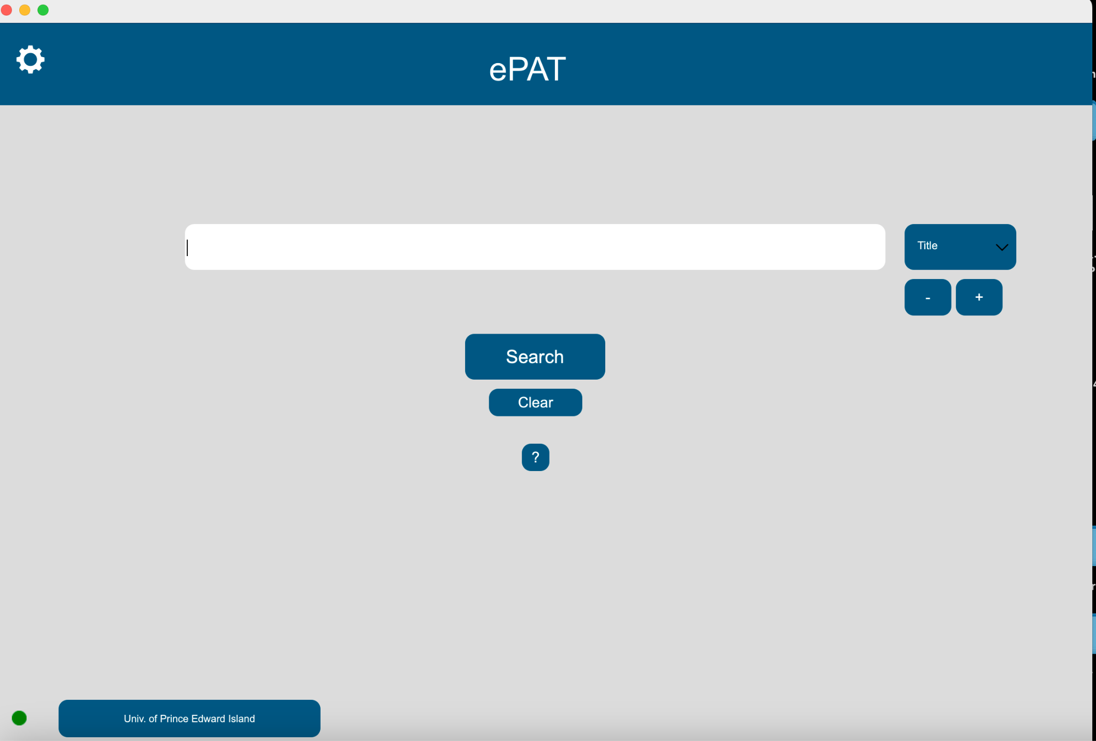

The main screen has a default of one search bar in the middle of the page.

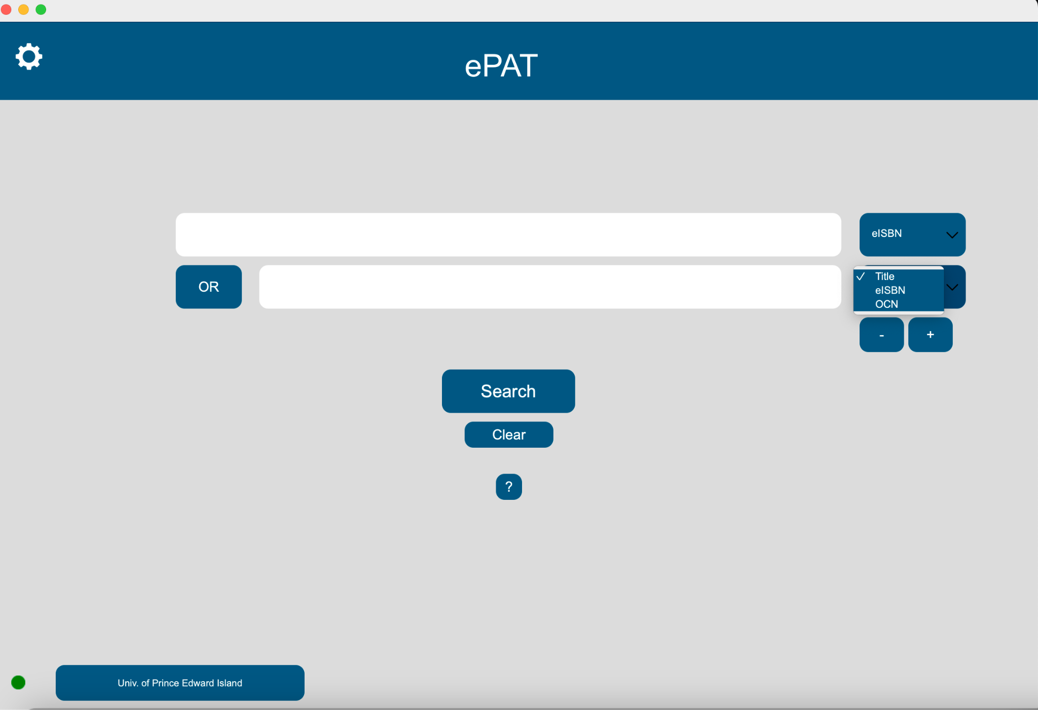

To the right is a drop-down list of ways to perform a search, i.e., via Title, eISBN and OCN.

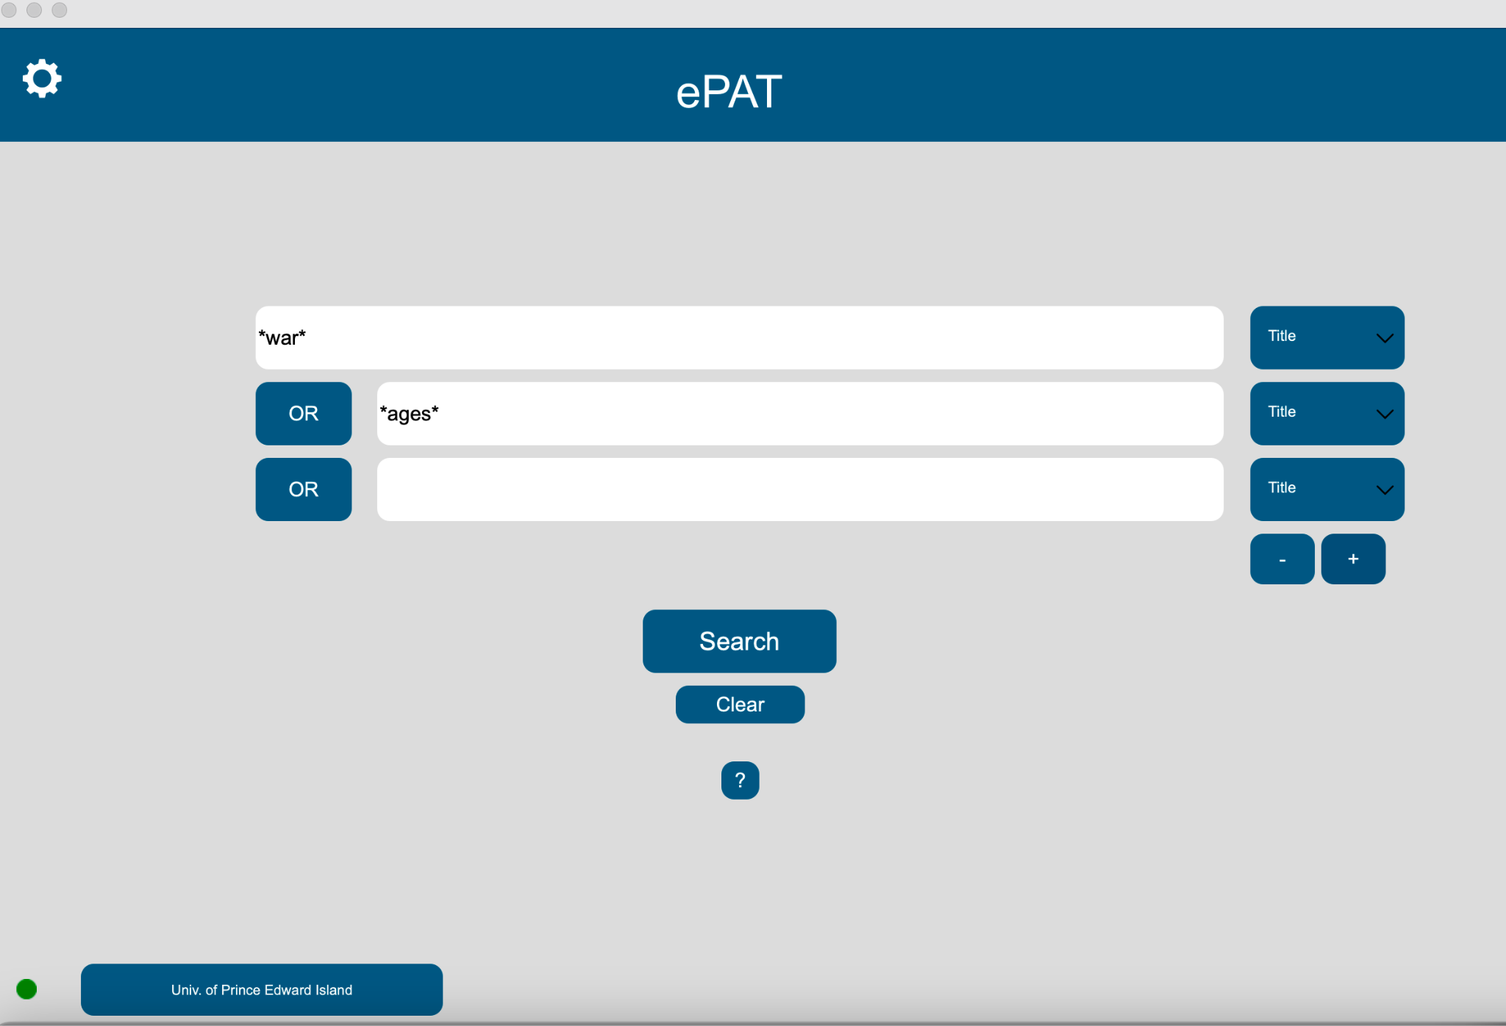

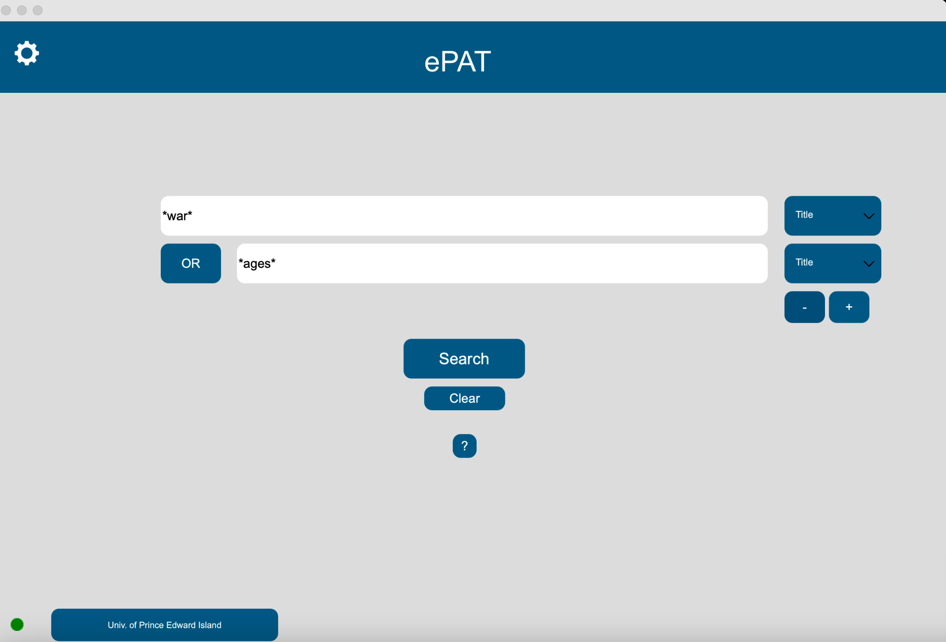

At the bottom of the drop-down, to select the type of search to be performed are the ‘+’ and ‘-’ buttons, which are used to add or delete search bars.

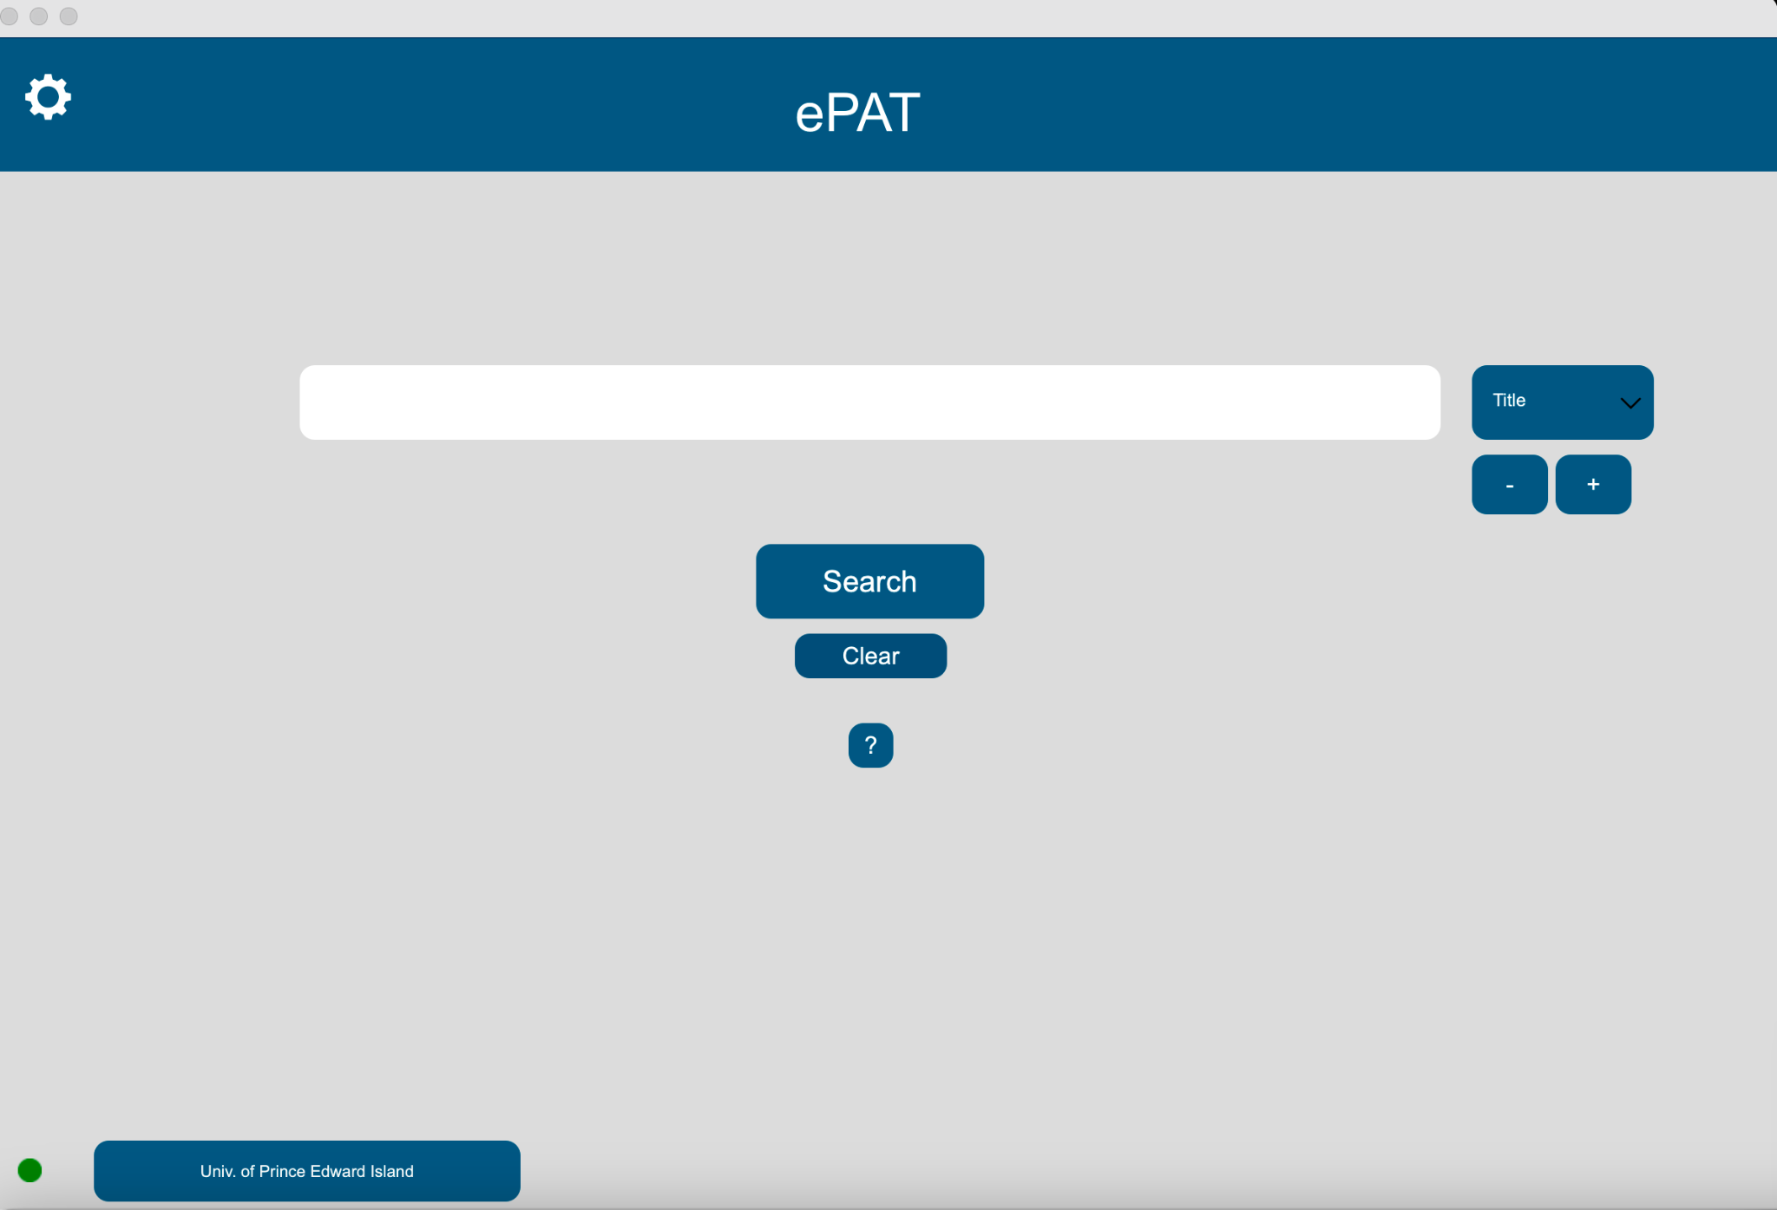

The ‘clear’ button sets the page to the default settings, i.e., One search bar present on the screen with ‘title’ selected as the default search-type.

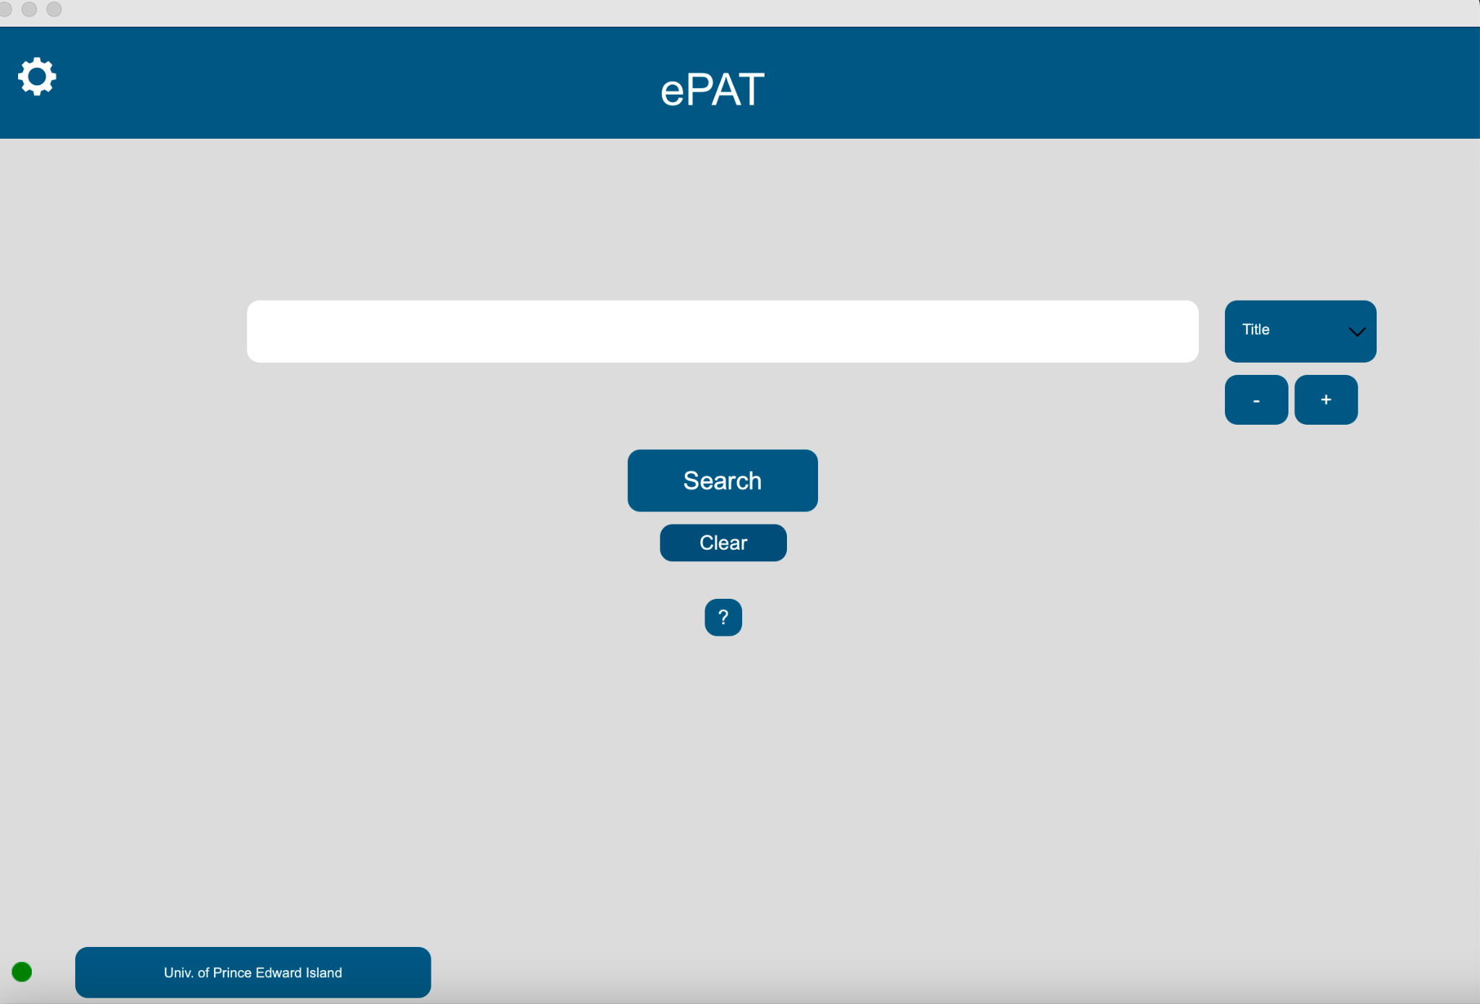

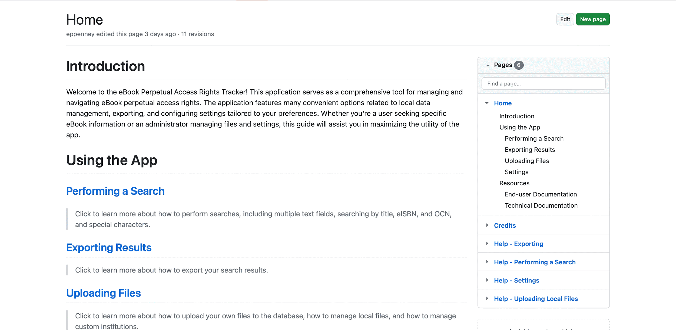Clicking the ‘?’ button under the Clear button takes the user to the GitHub repository for any help needed.

2. THE RESULTS PAGE

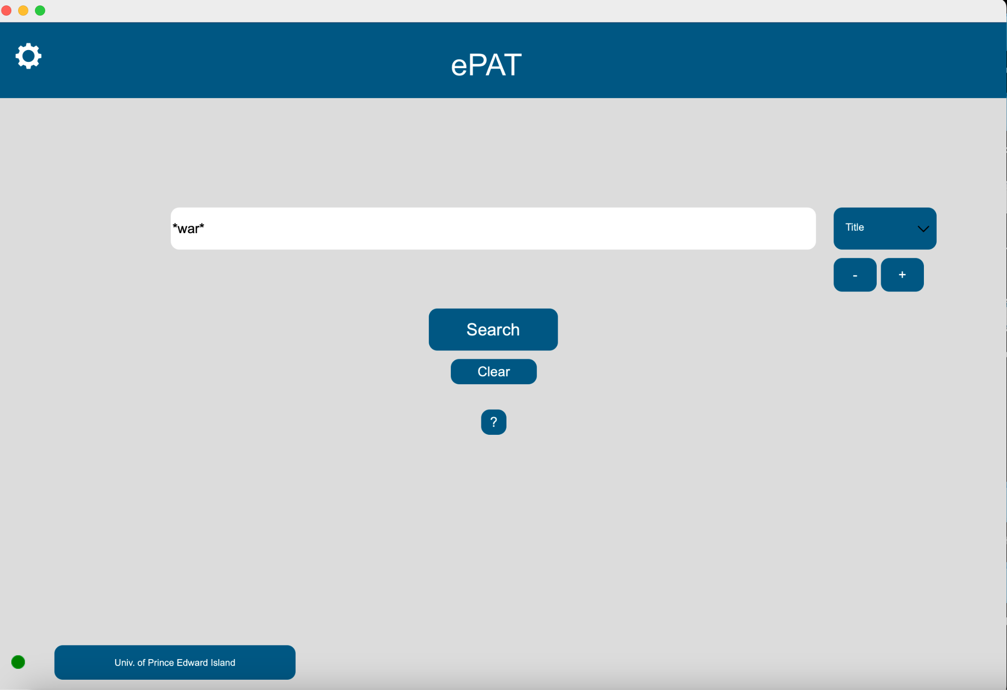

Once the user enters the search they would like to perform, They can select the ‘Search’ button below the search bar or hit ‘Enter’ on their keyboard.

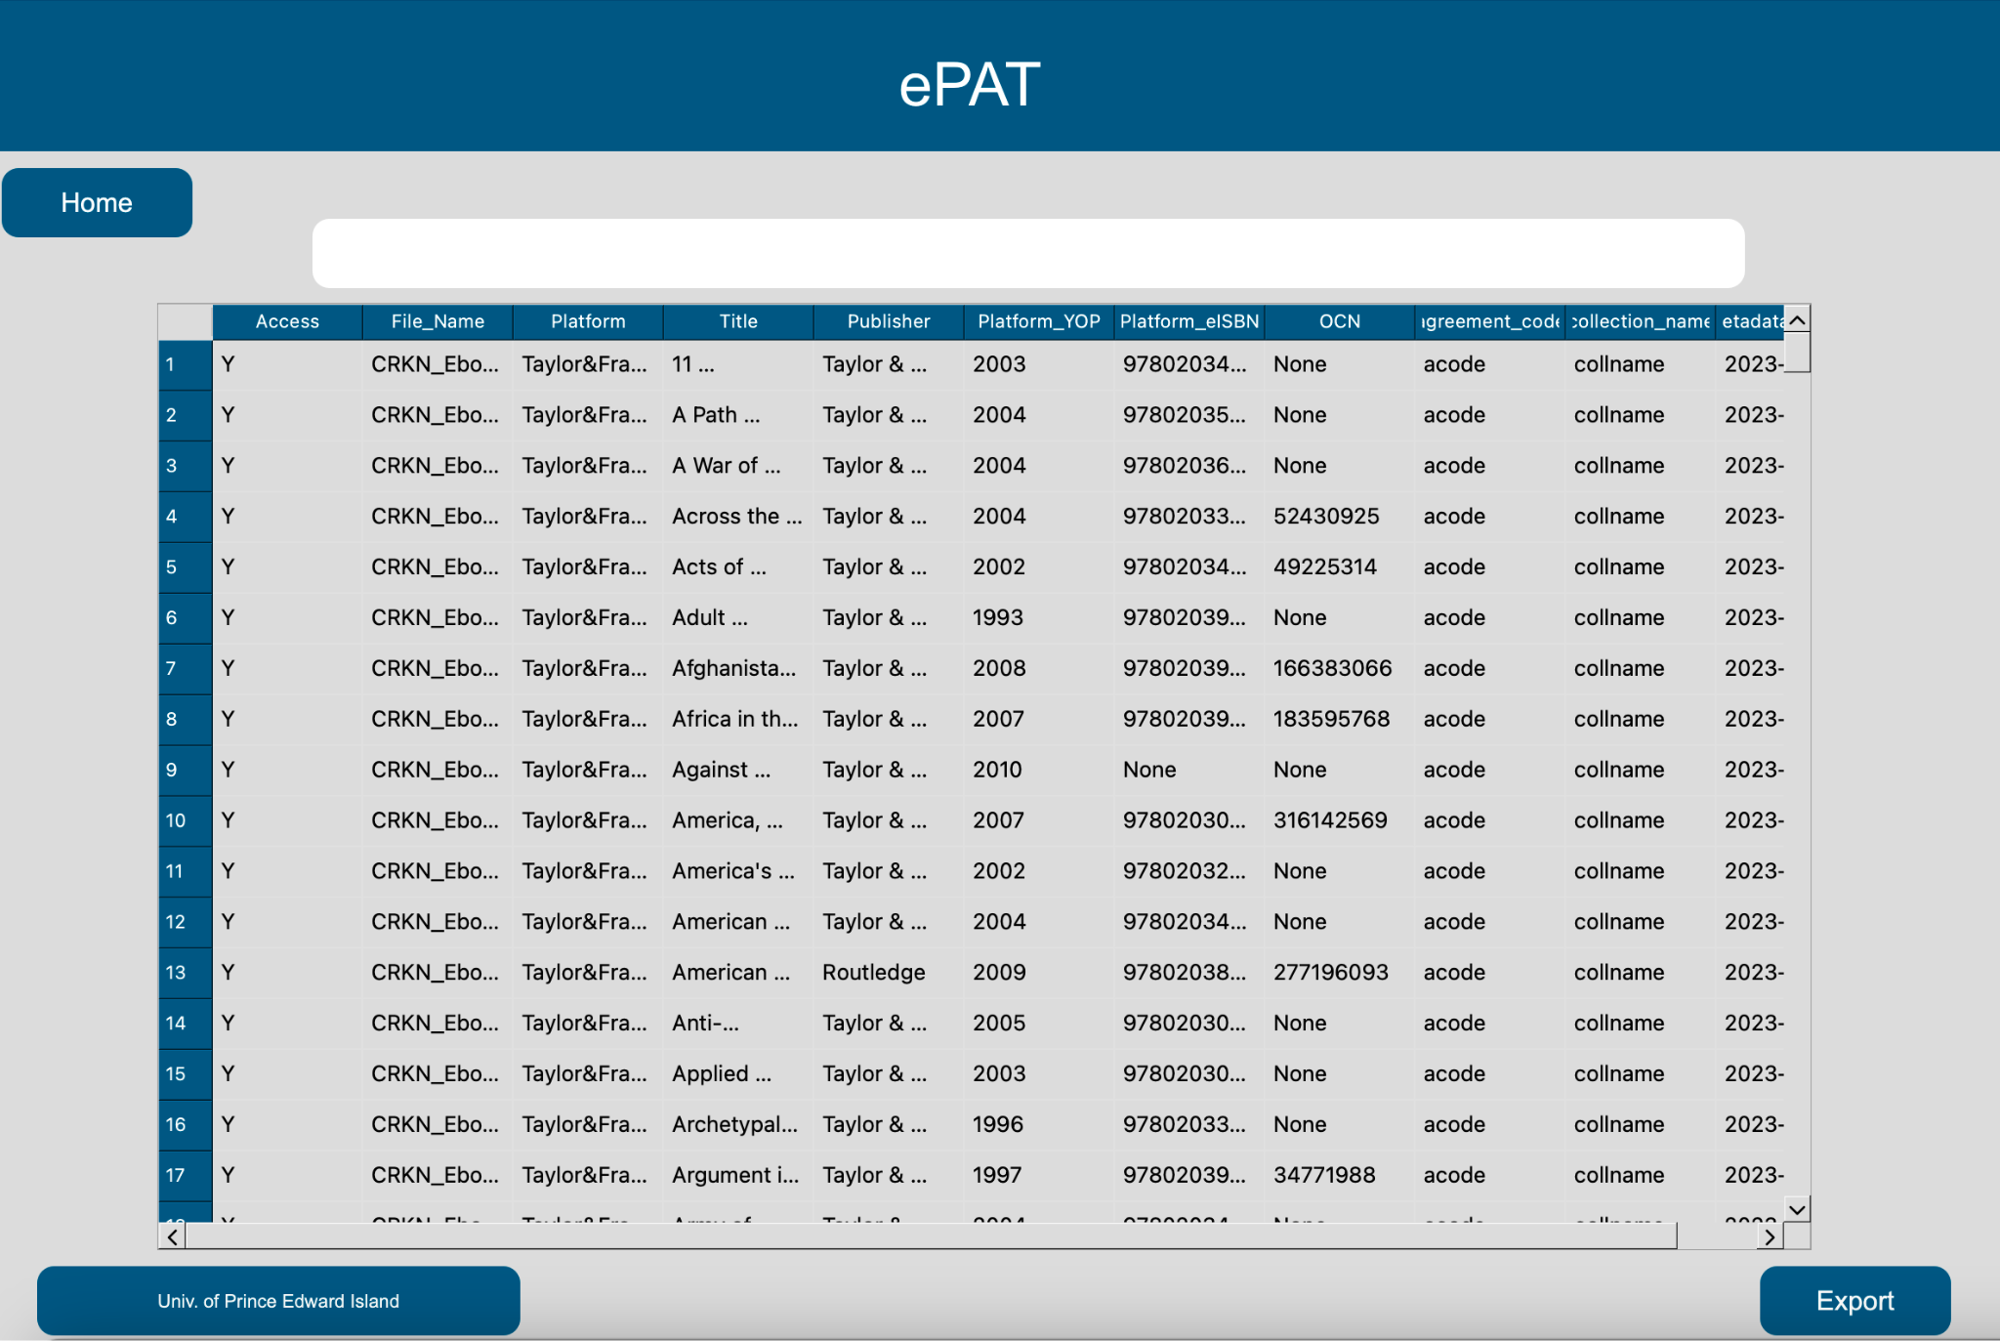

Once the search is complete, the Results page, with the results displayed in a tabular format will appear. The first column displays whether the eBook for the institution (named at the bottom left) with a ‘Y’ or ‘N’ stating Y for yes and N for no to having access rights.

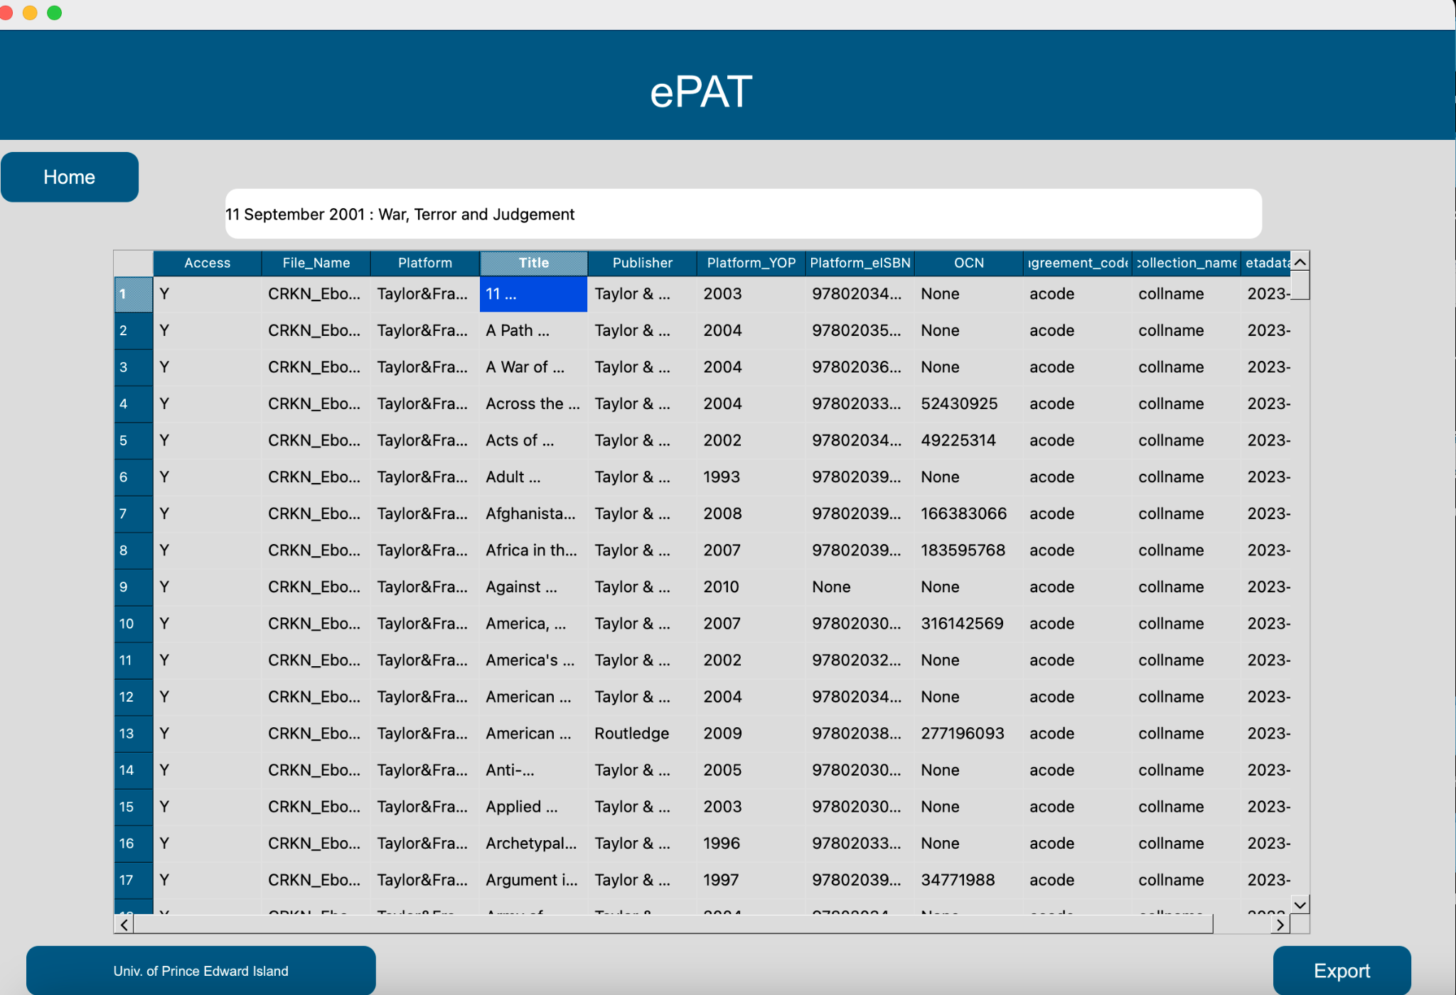

To view any specific field of the table, users can select any cell in the table and its contents will appear in the white box at the top of the screen.

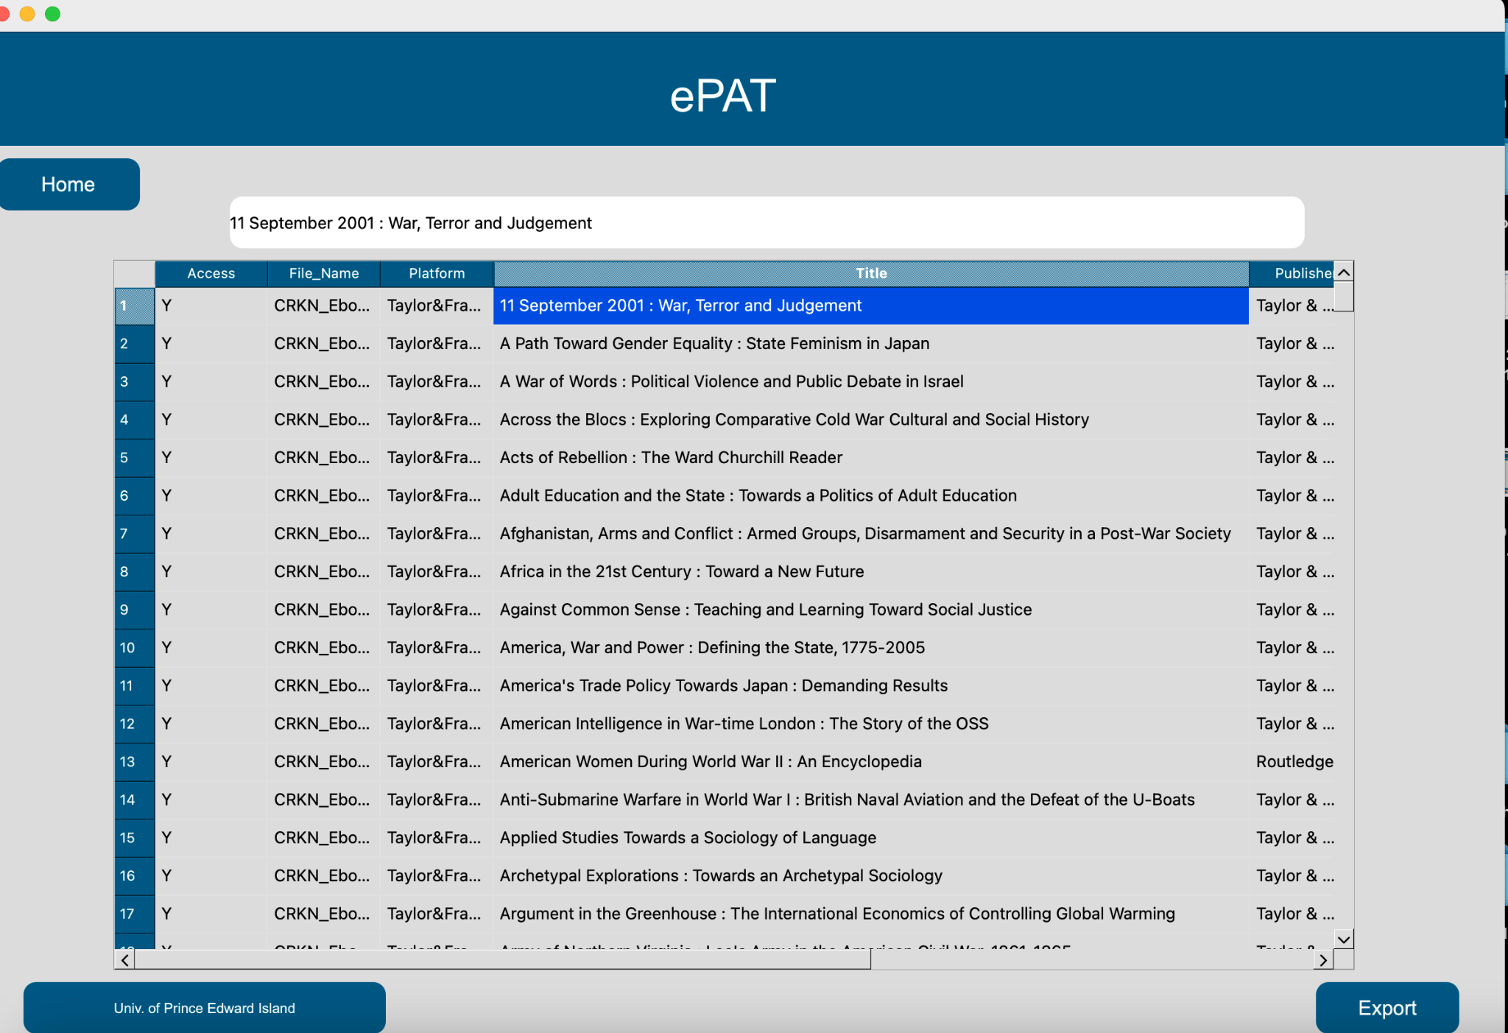

The user can also resize any column by dragging it on the screen.

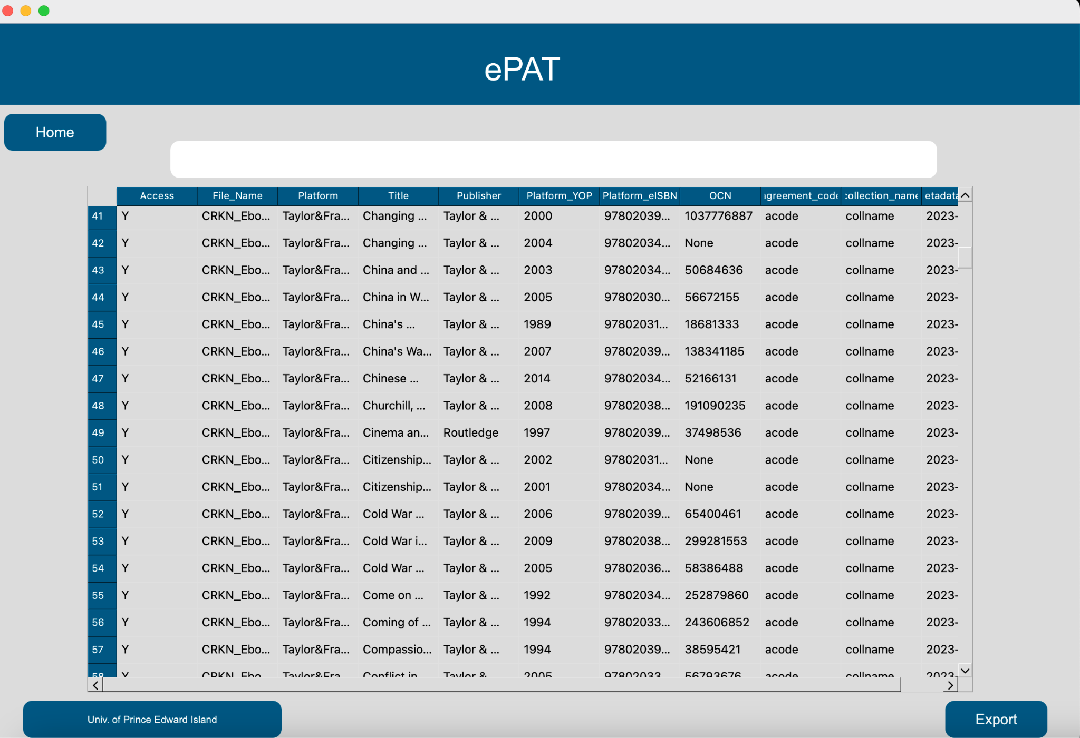

The scroll bars helps navigate up and down the page and provides left to right navigation.

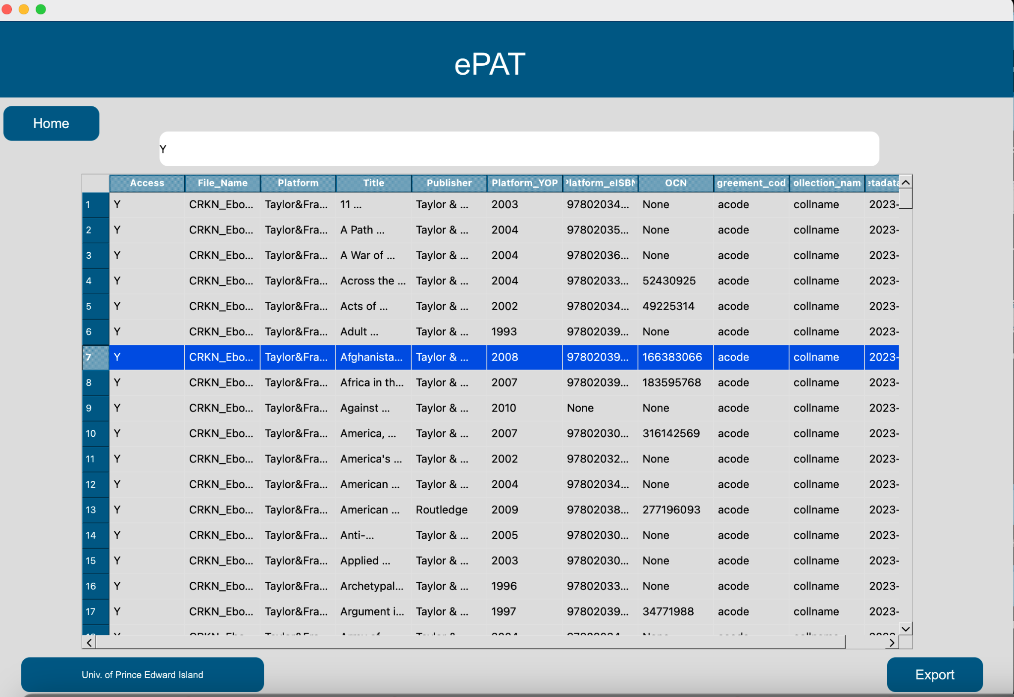

Selecting the desired column number highlights the whole row for ease of navigation.

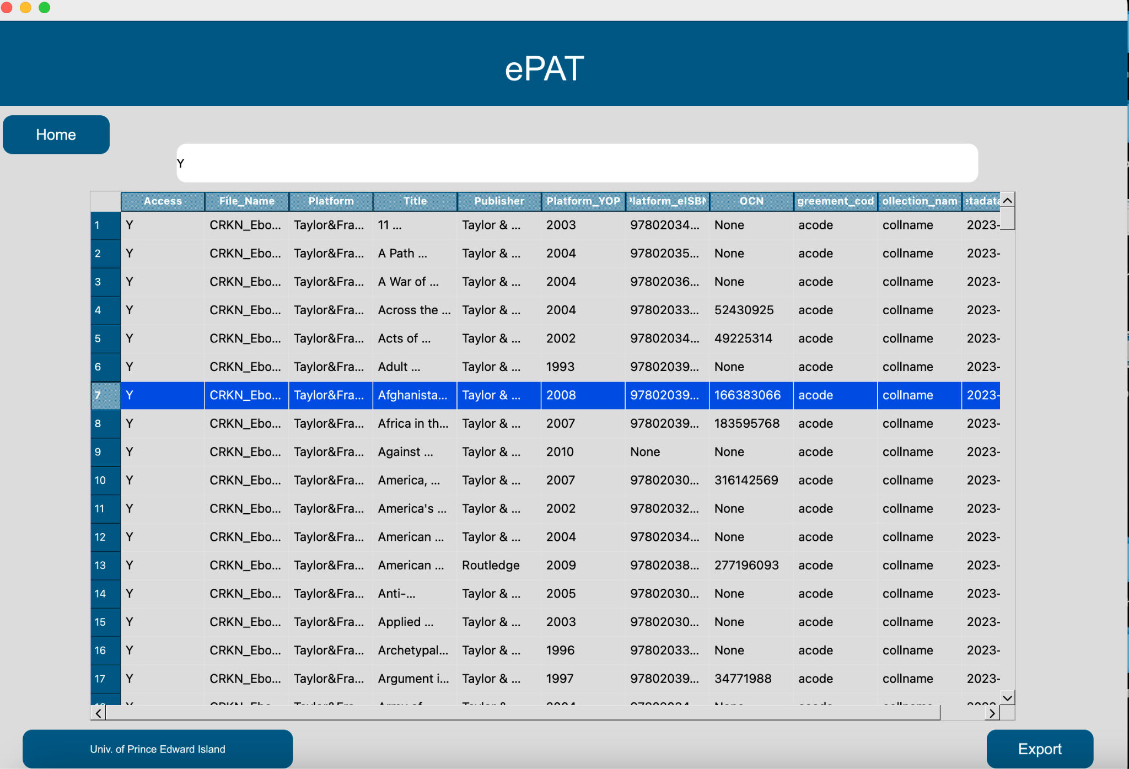

The user can also export search results into their system by clicking the ‘Export’ button at the bottom right of the screen.

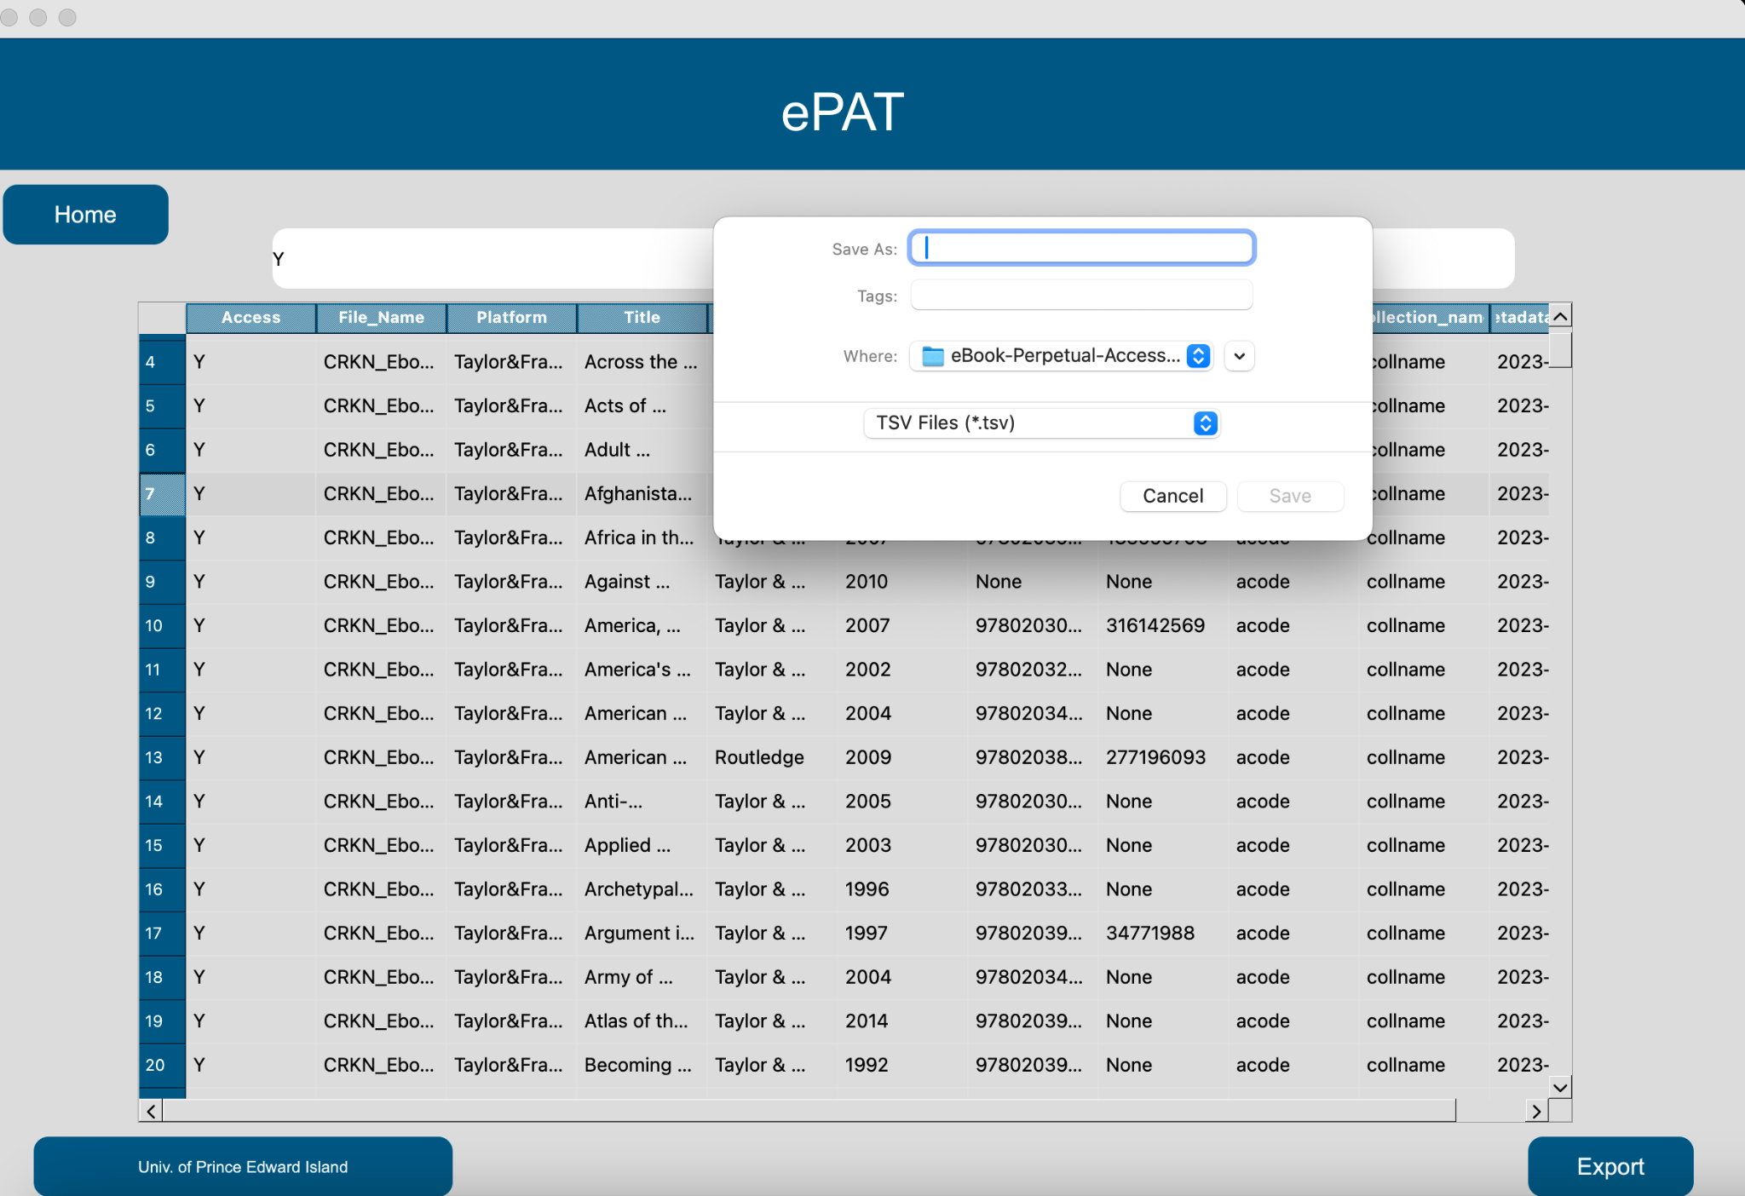

The user can select the desired name and location to save the file and hit ‘Save.’



If the user hits ‘Cancel,’ the user returns to the results page.

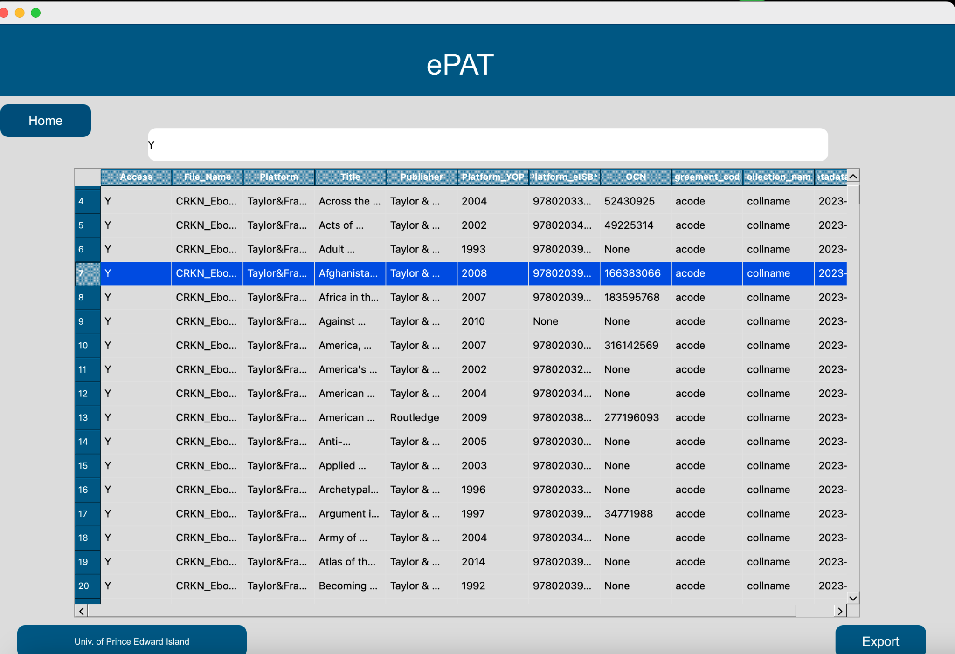

The user can click the Home button to return to the Home Page.

3. THE SETTINGS PAGE

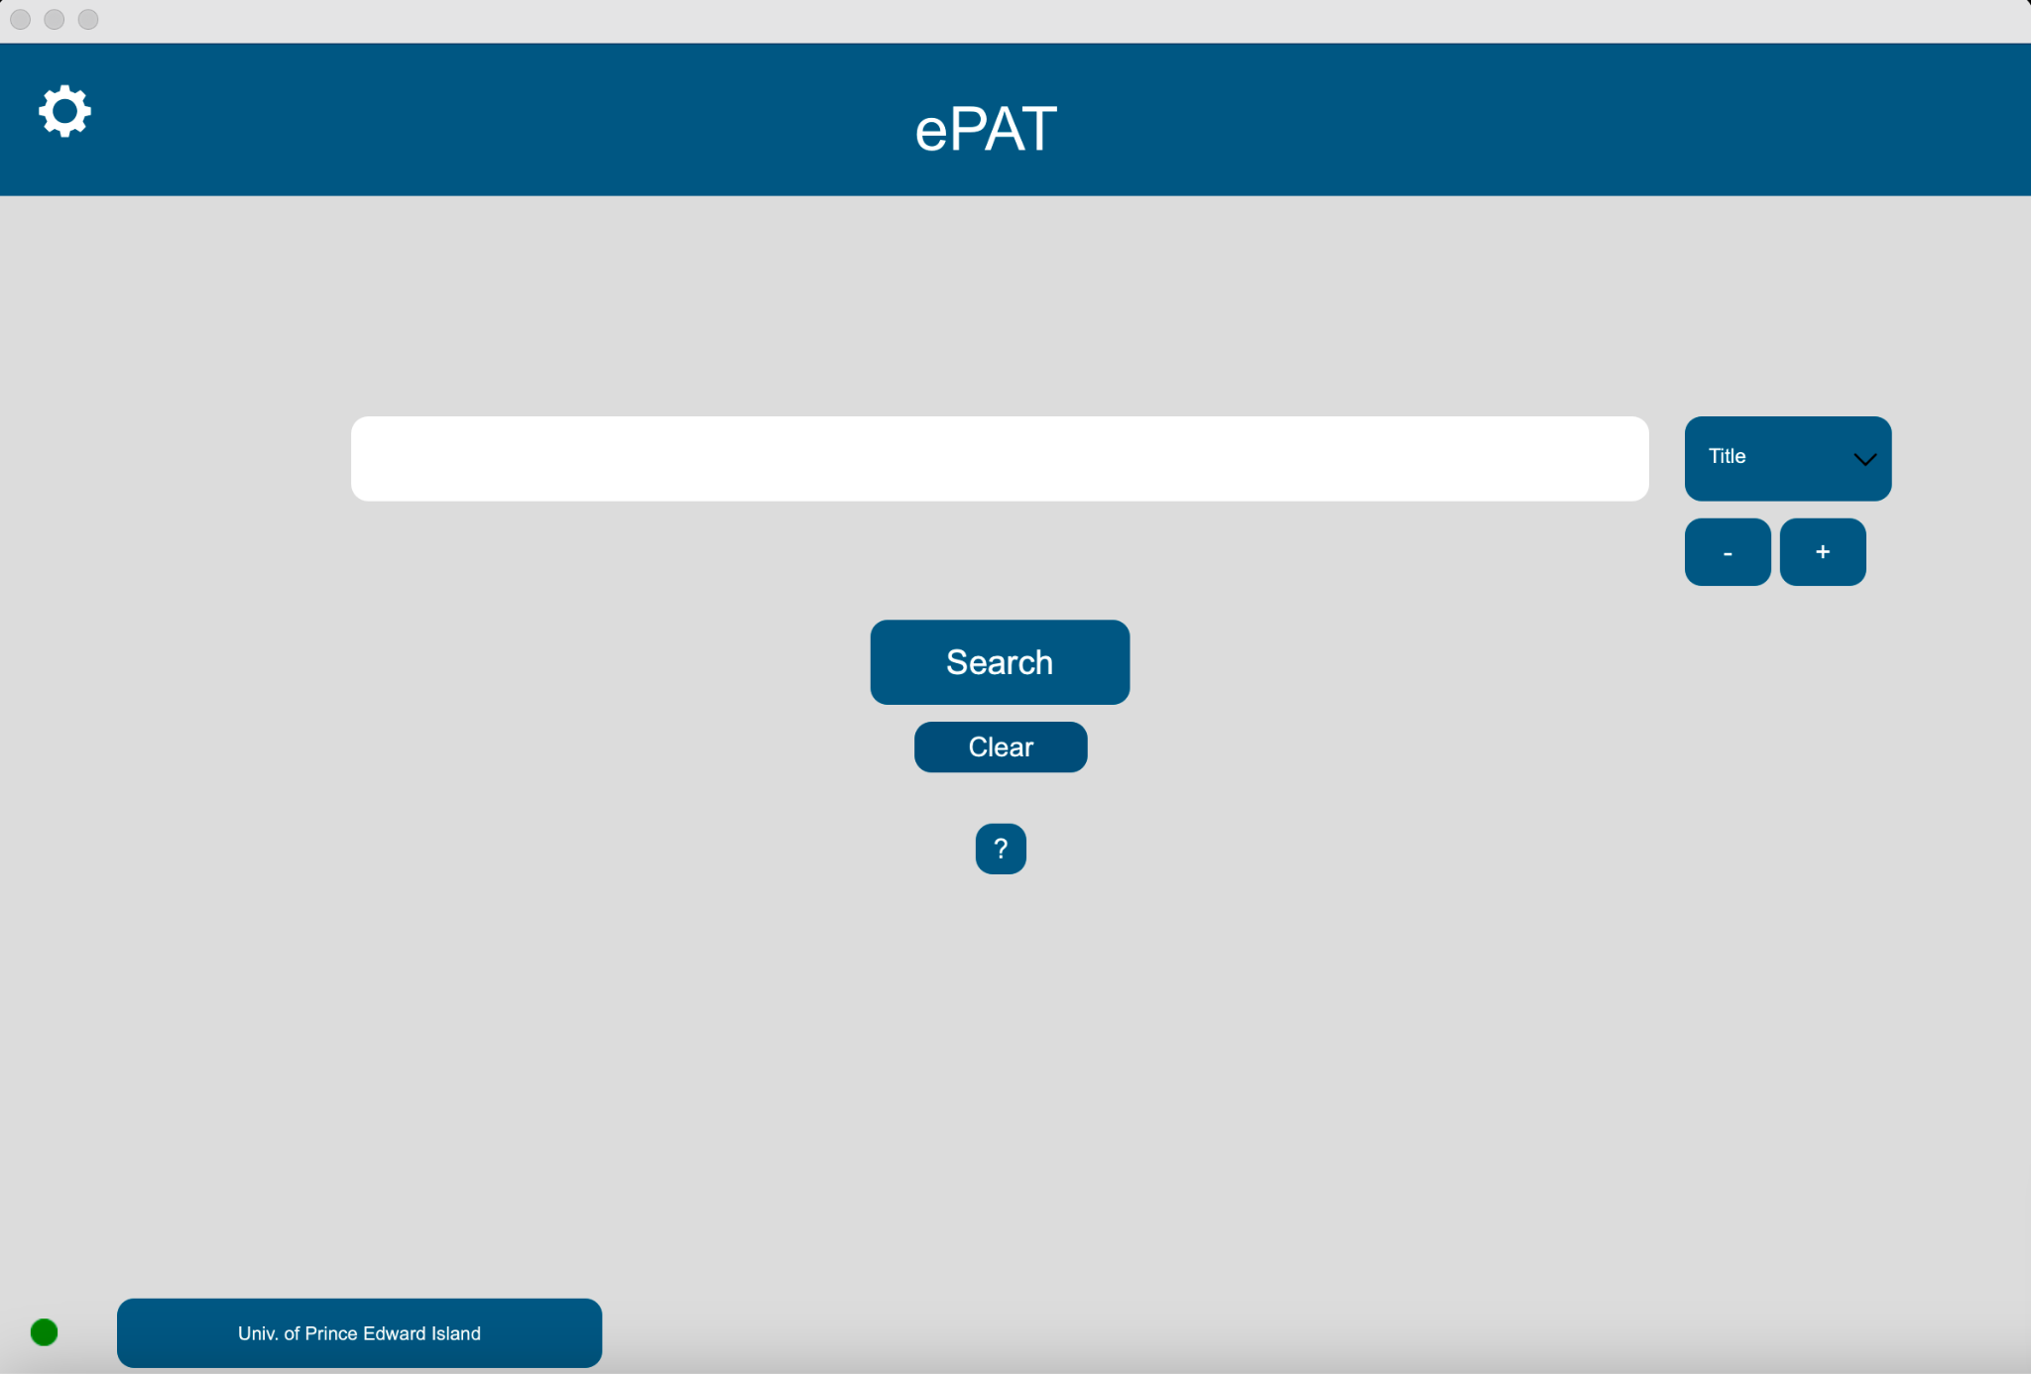

The user can click the ‘Settings’ or the gear icon to get the Settings page.

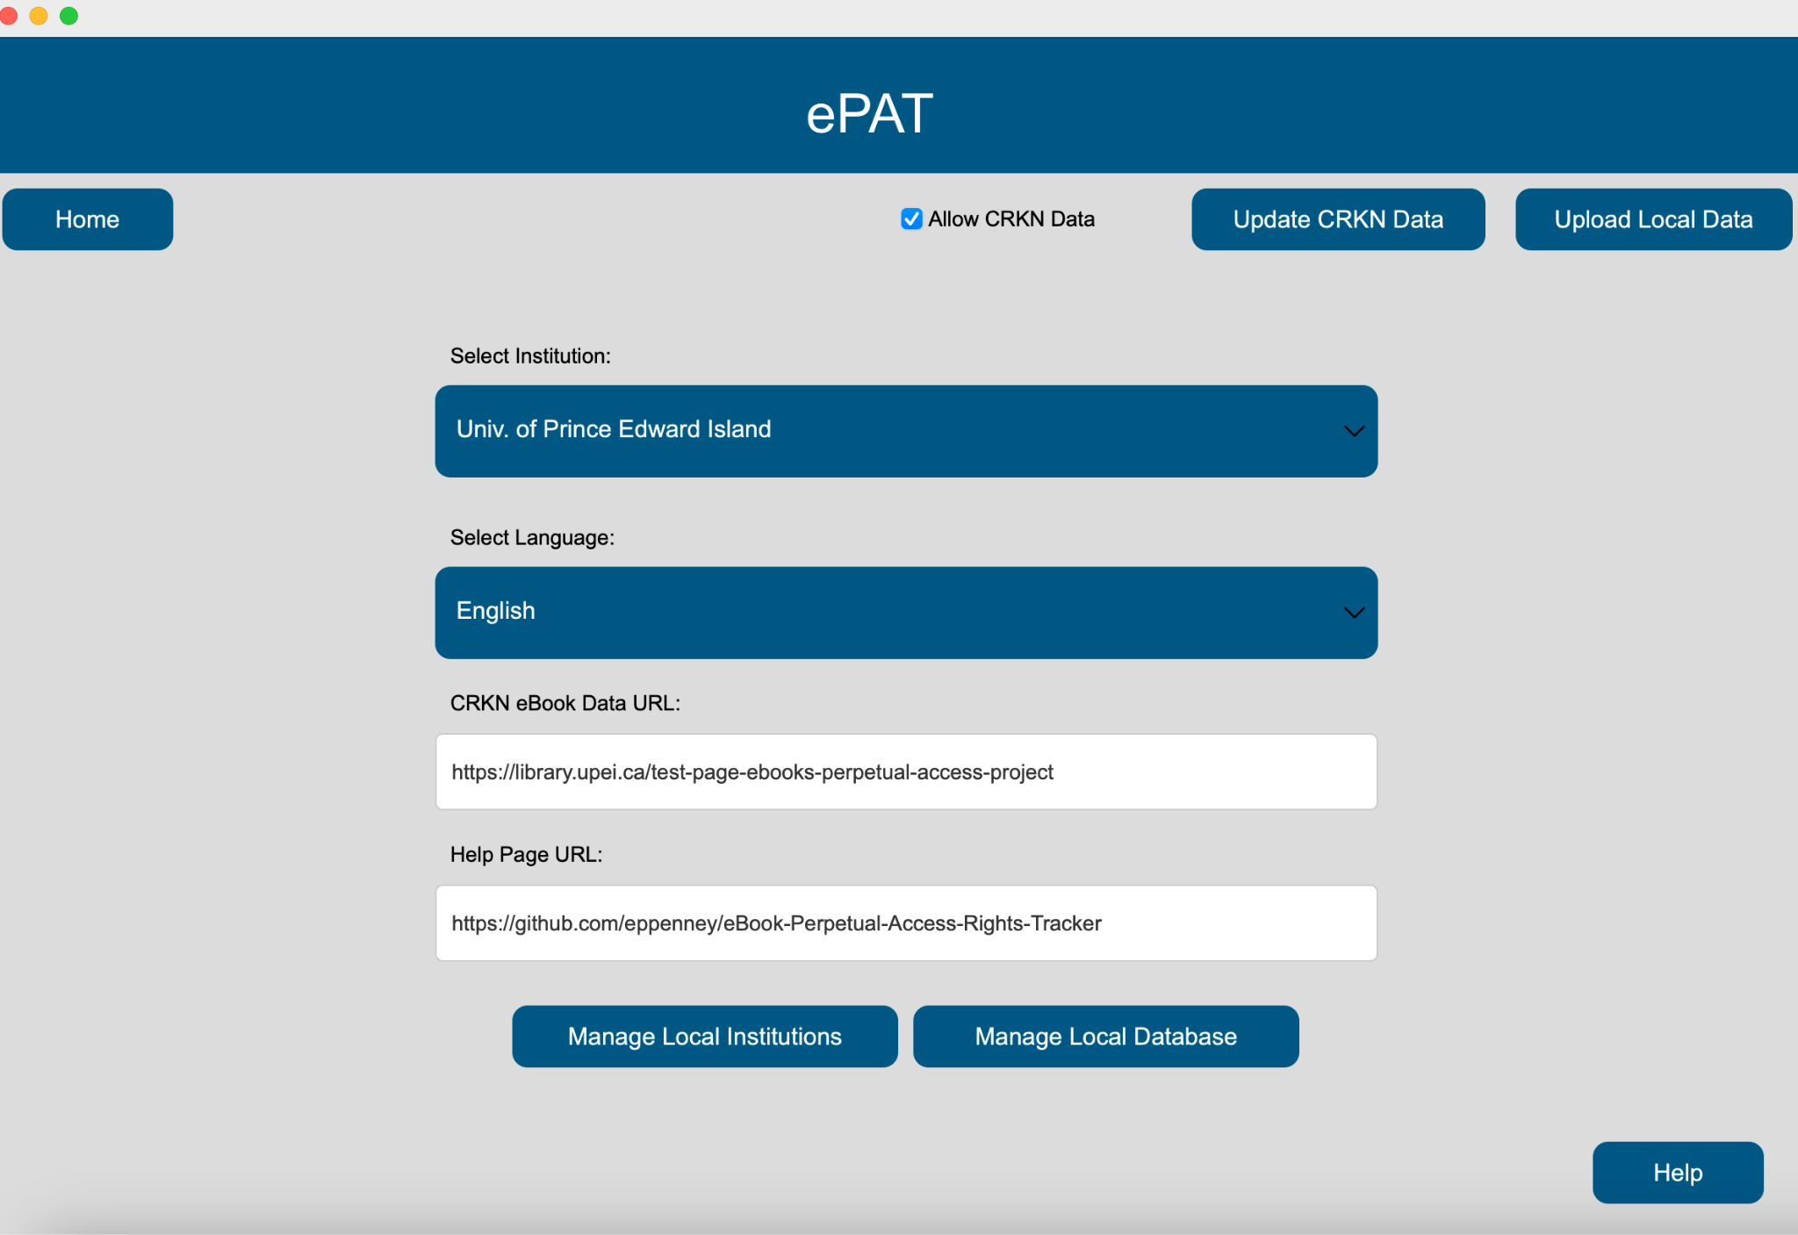

This is the Settings screen.

To the bottom of the page are two links - the top one for test data/sample for eBook PA rights sheet and the bottom one with the link to the GitHub Repository.

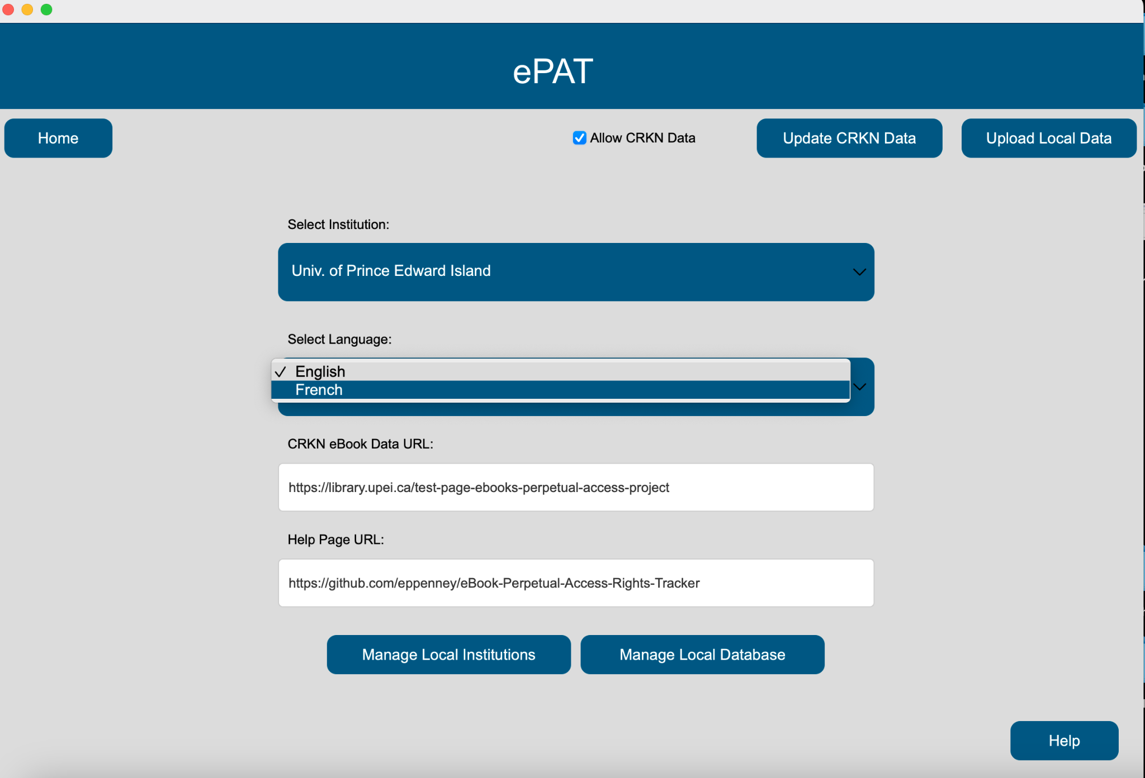

The user can select the desired language for the whole application by selecting the desired language from the language drop-down menu.

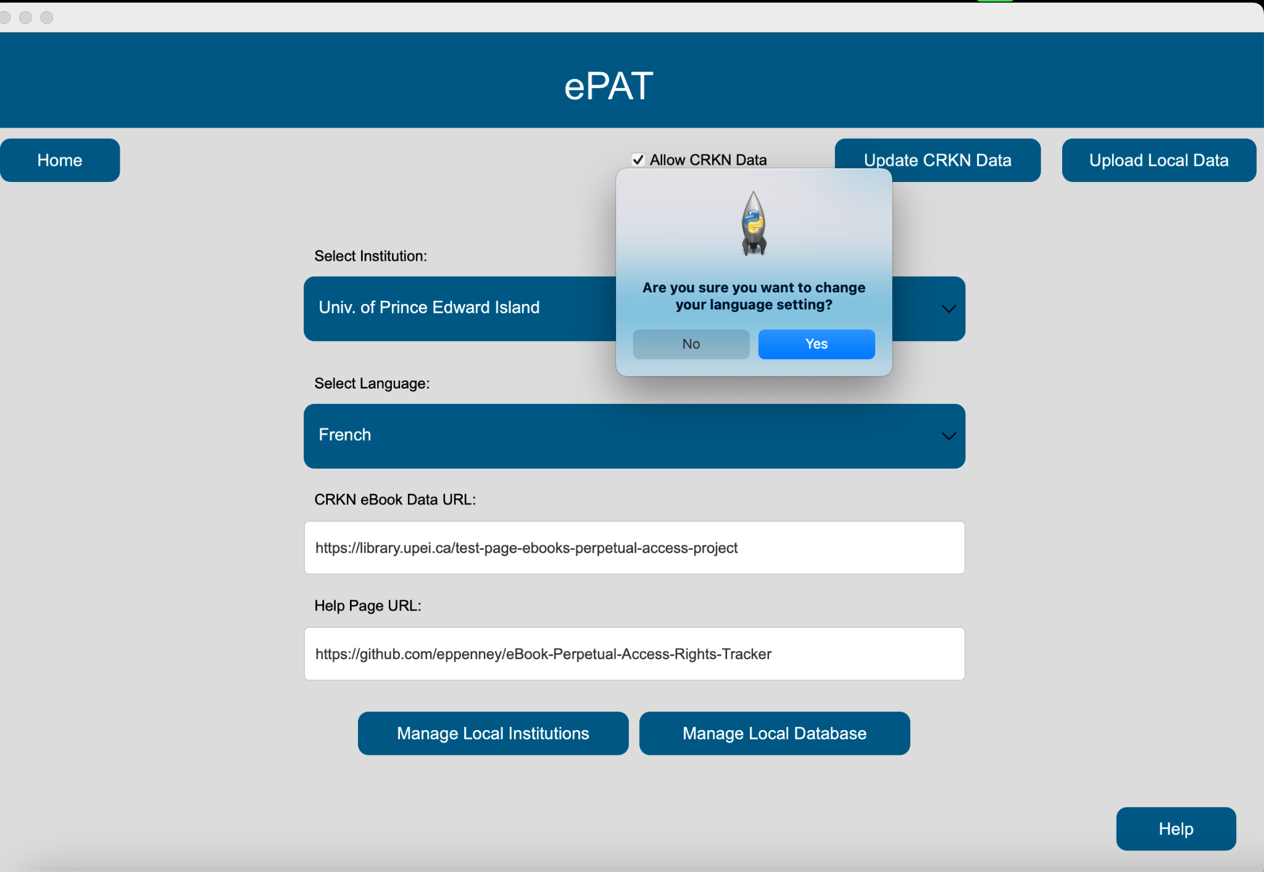

Once the user selects the desired language, a confirmation message pops up to save the desired selection. This will change the entire application to the desired language.

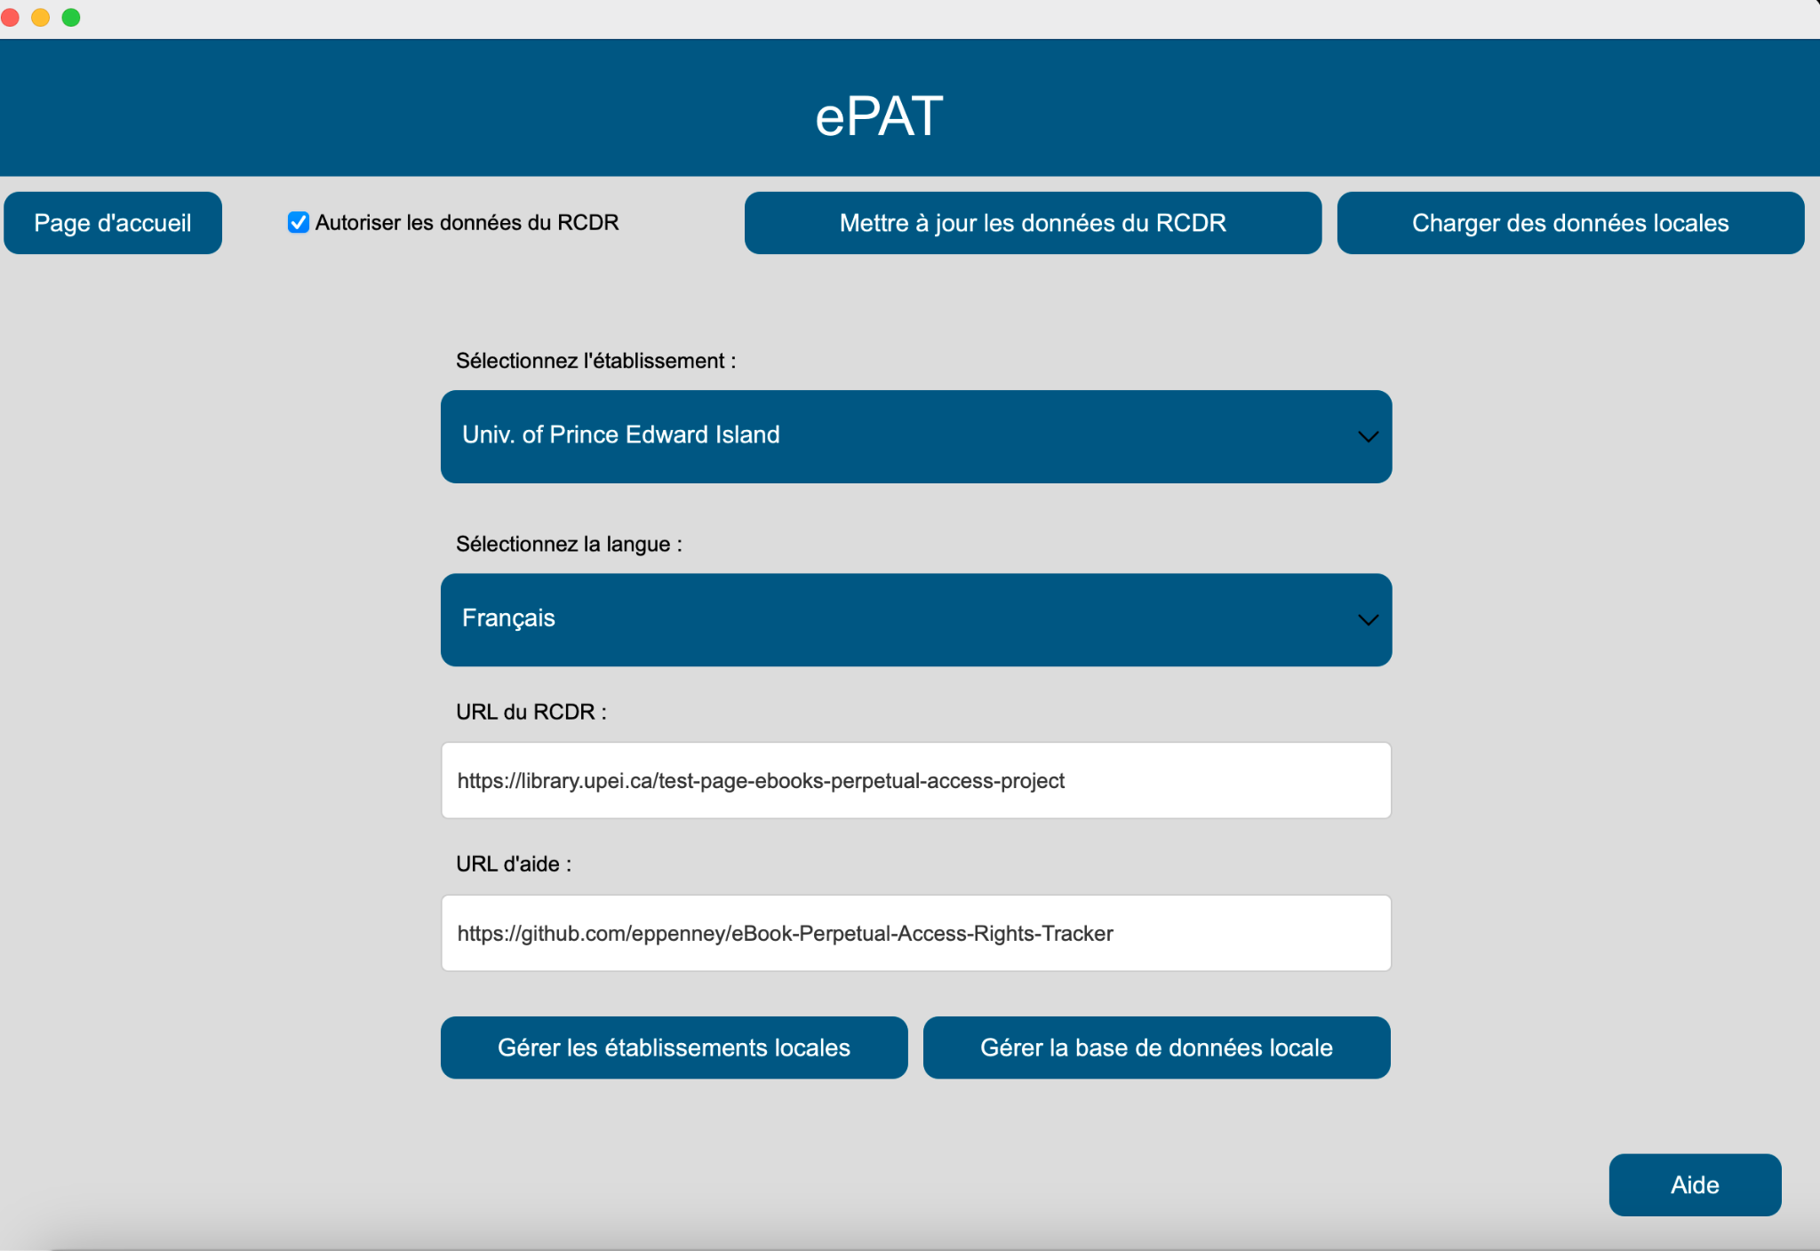

Settings page is translated to the French language.

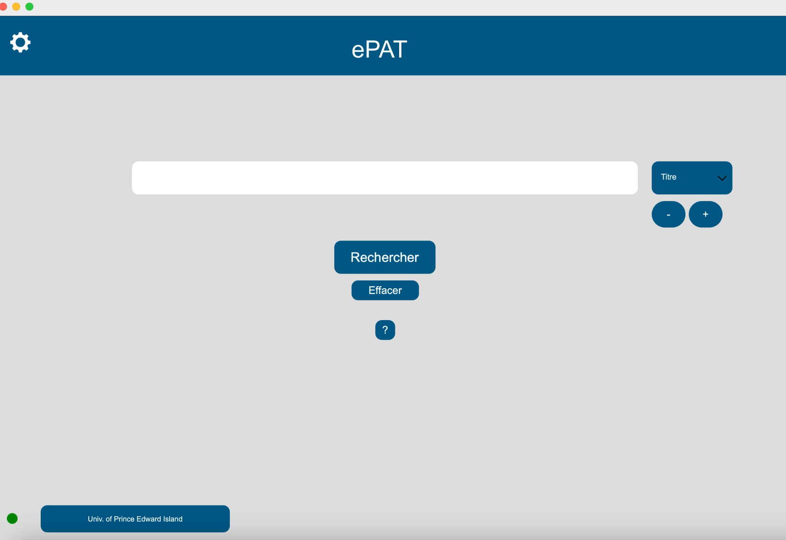

Main screen (Home page) in French.

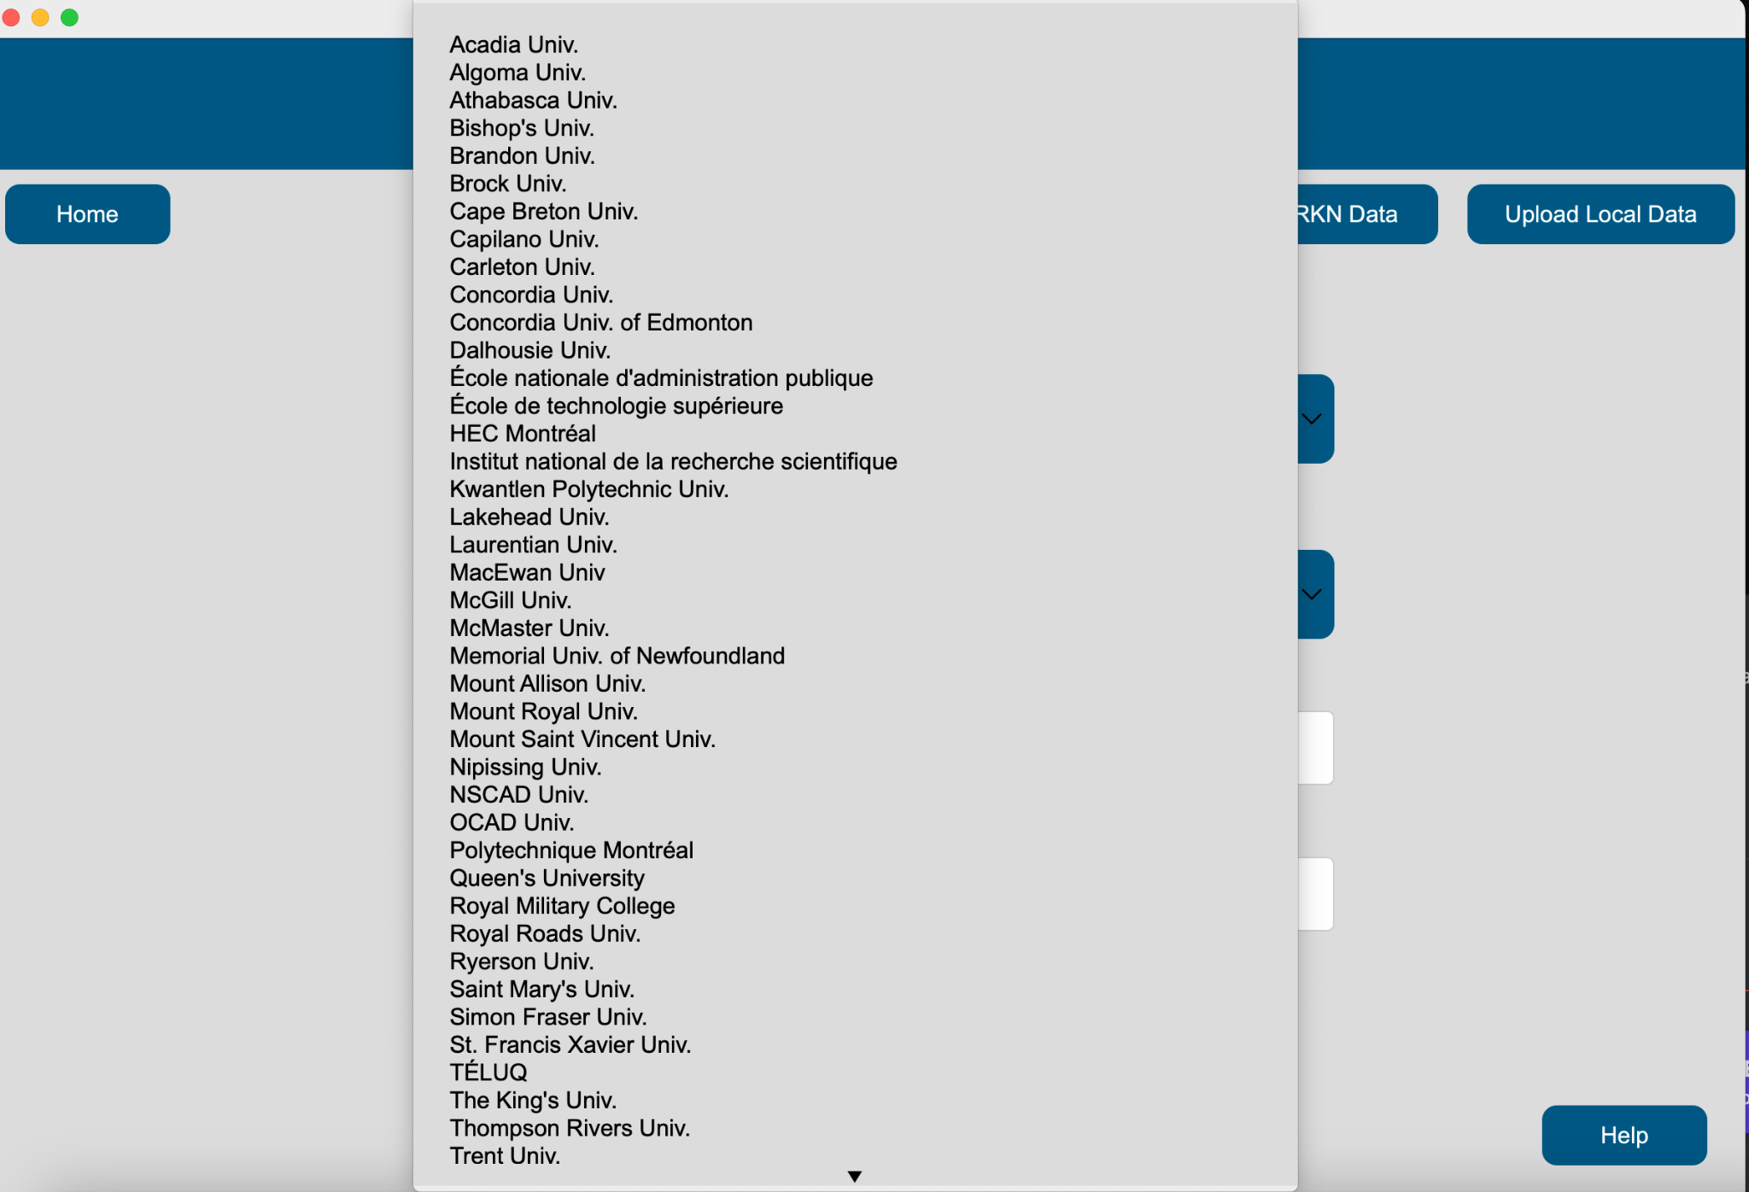

The user can also change/select the desired institution from the ‘Select Institution’ drop-down menu.

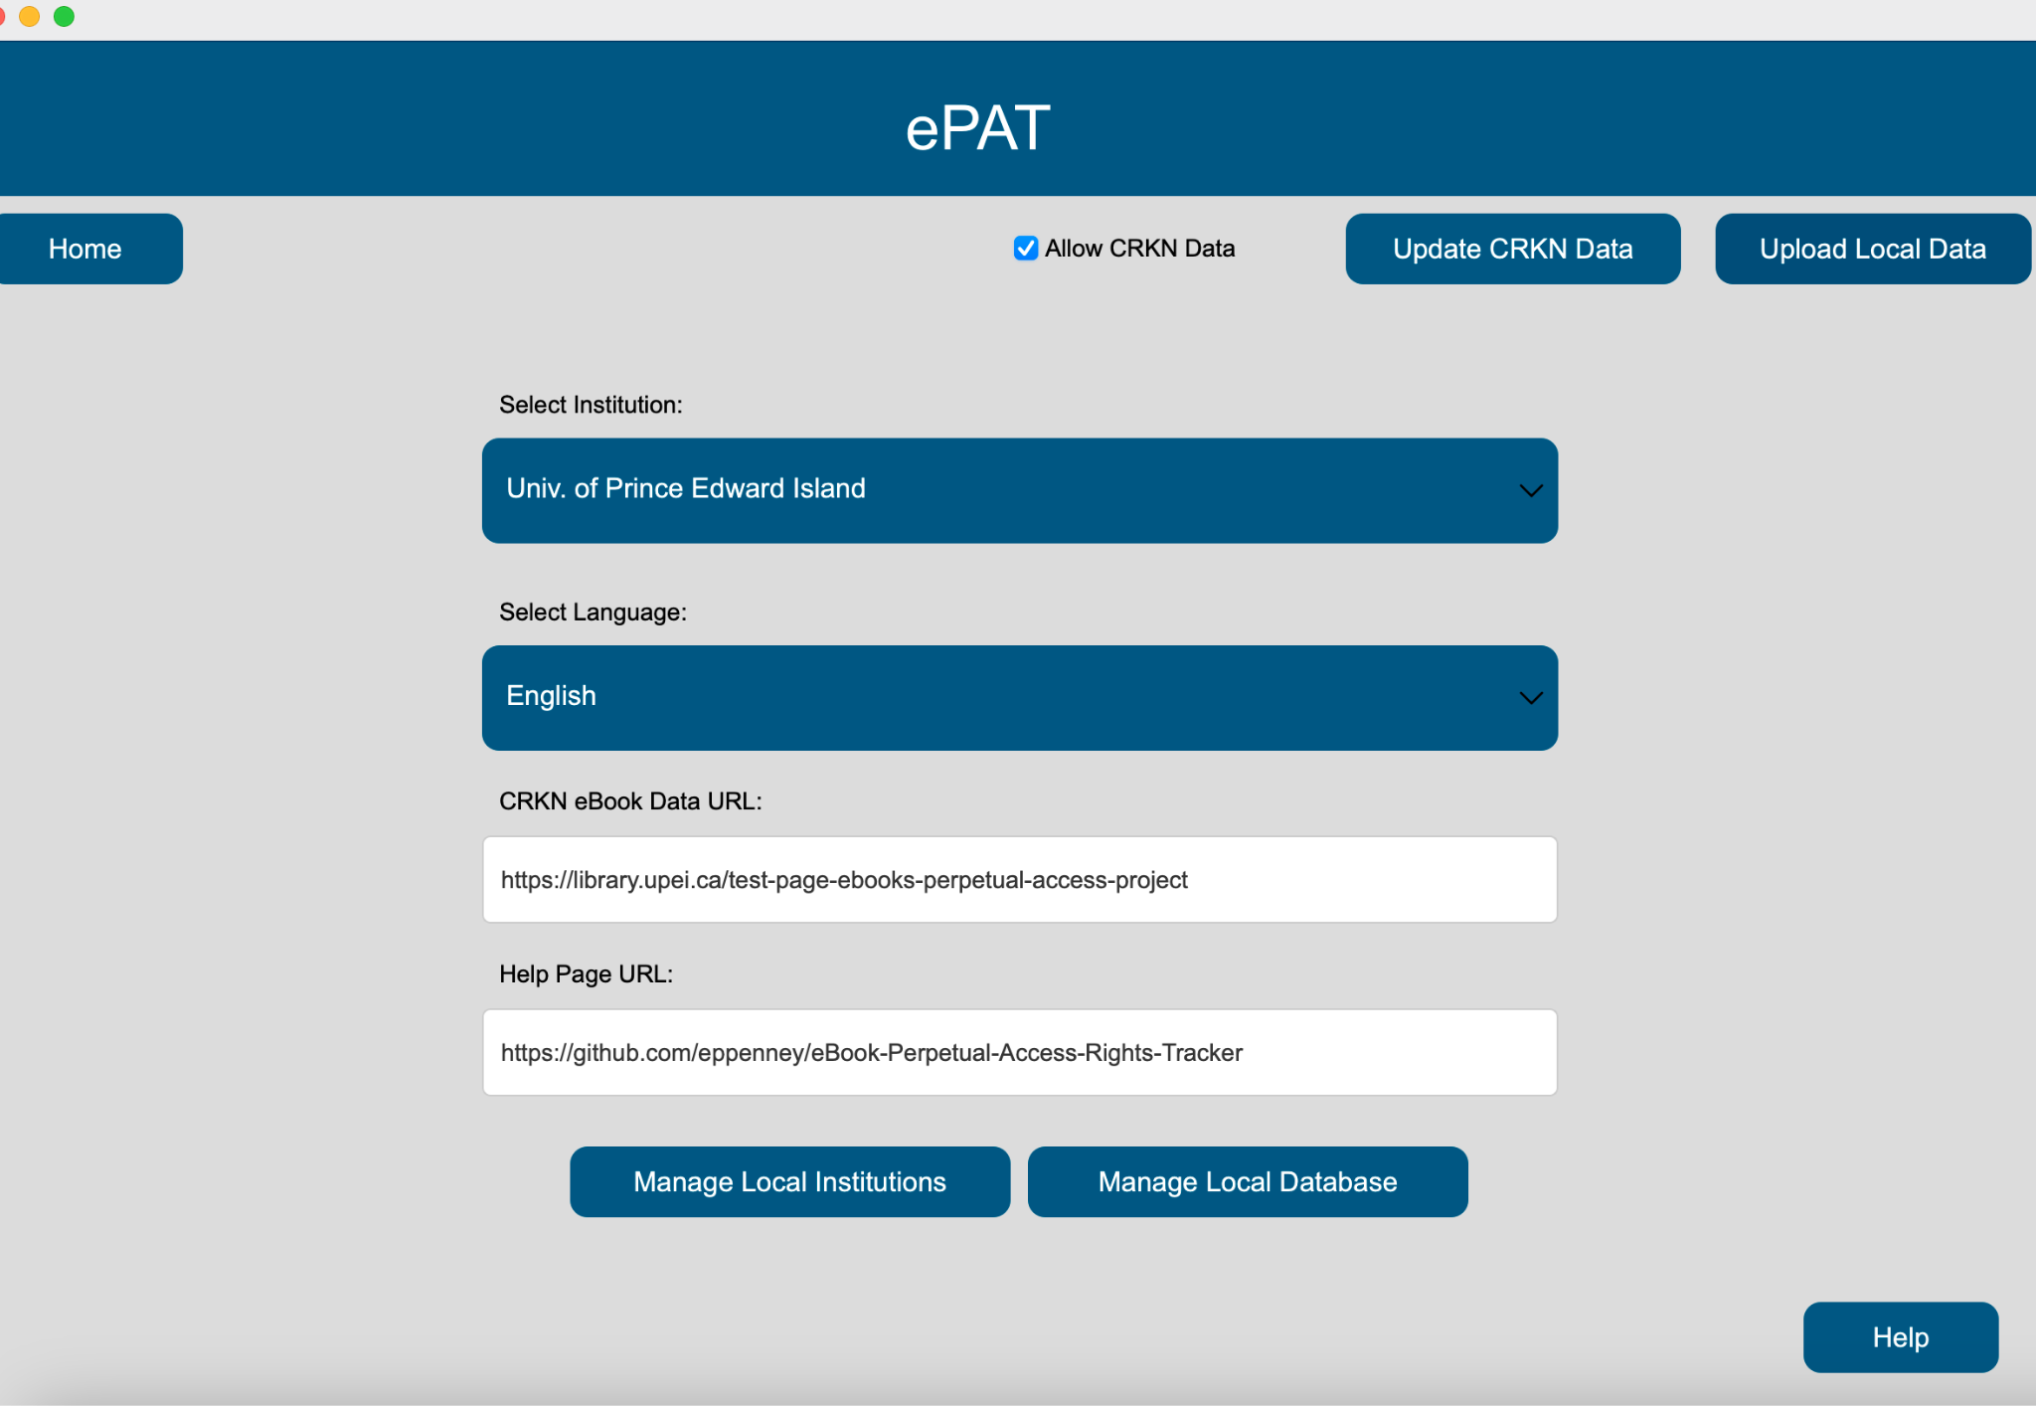

The user can also upload their local files from their own computer into the system database.

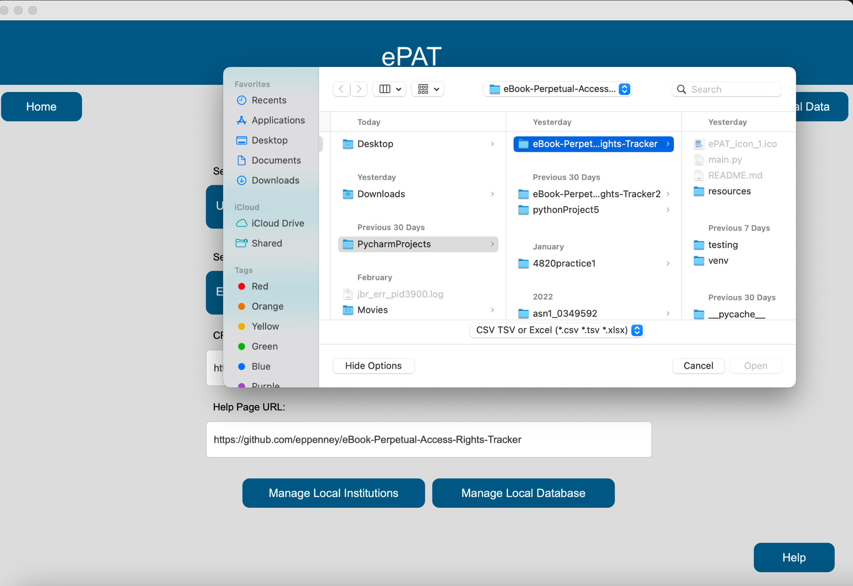

A pop-up appears asking the user to upload files. The user can choose the file(s) they would like to upload or hit the cancel button to go back to the settings page.

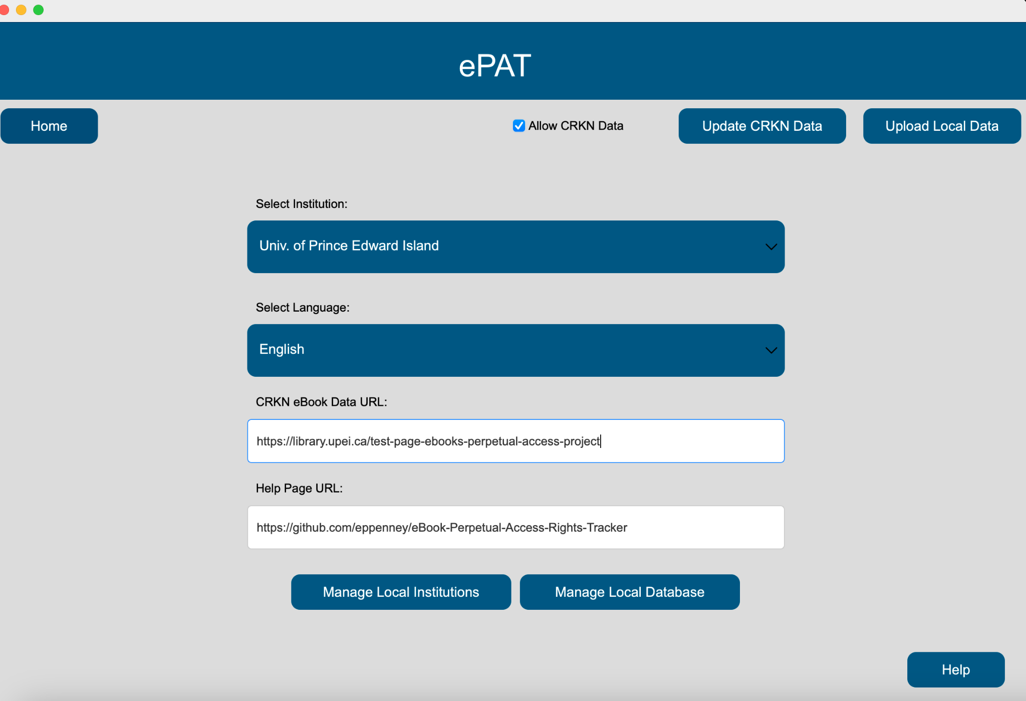

The user can hit the Help button to the bottom right of the page to visit the GitHub repository for any help required.



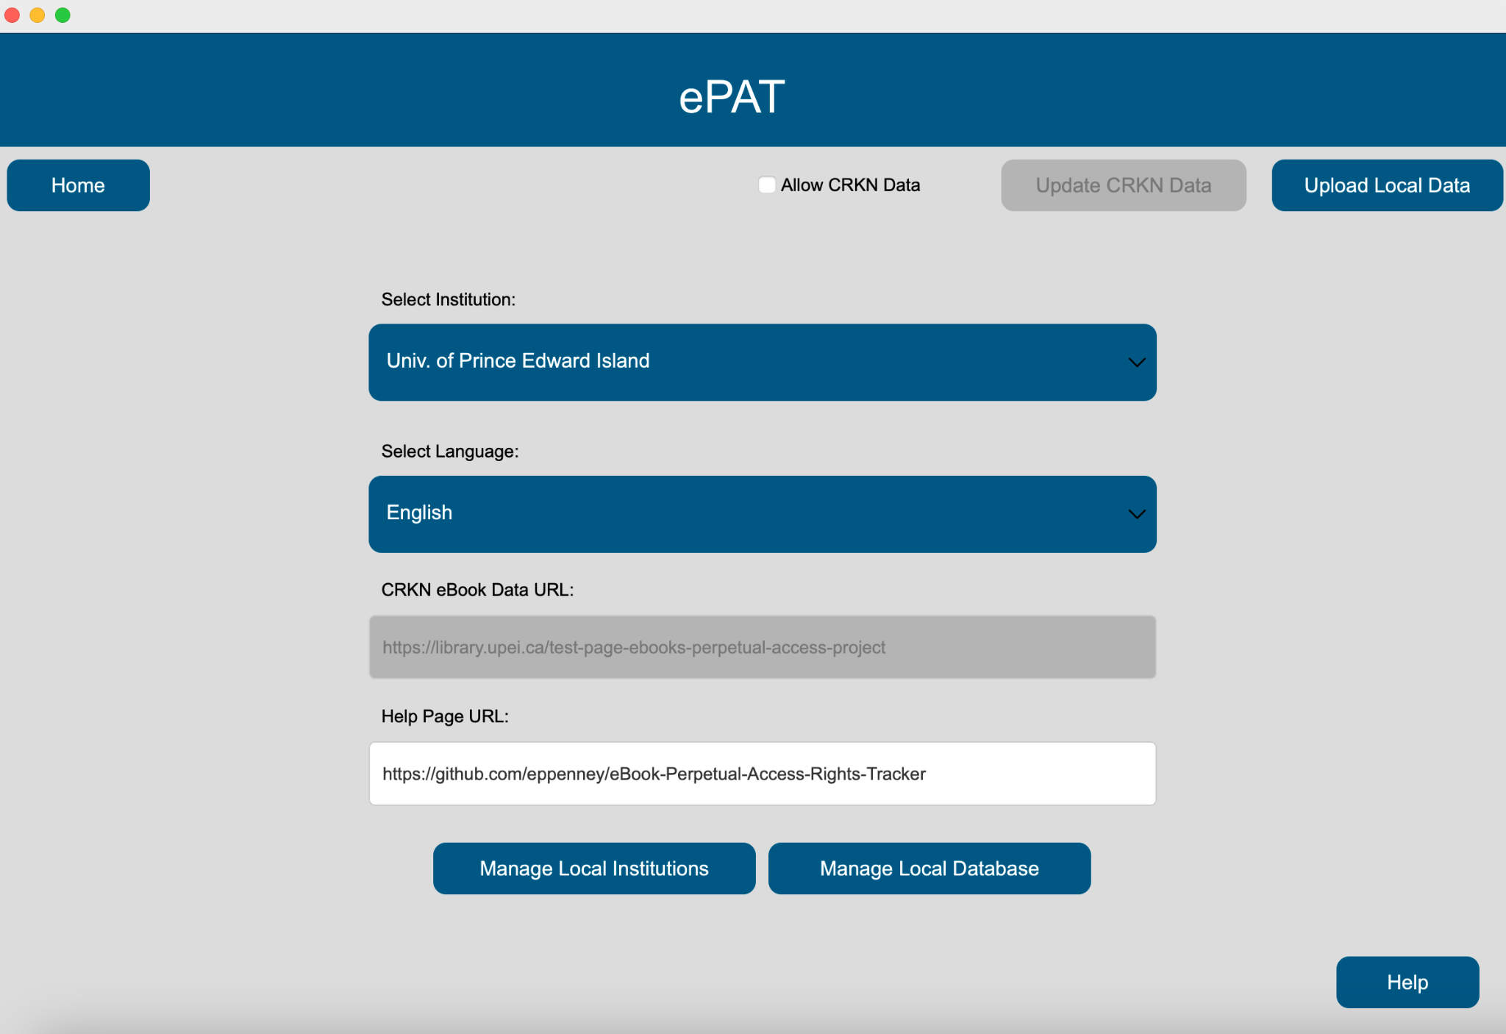

If the user de-selects the checkbox of ‘Allow CRKN Data,’ the application will block access to updating the CRKN data files in the database and modifying the URL for the CRKN website where the data files are stored. Any searches will also only contain results from local files uploaded to the database.

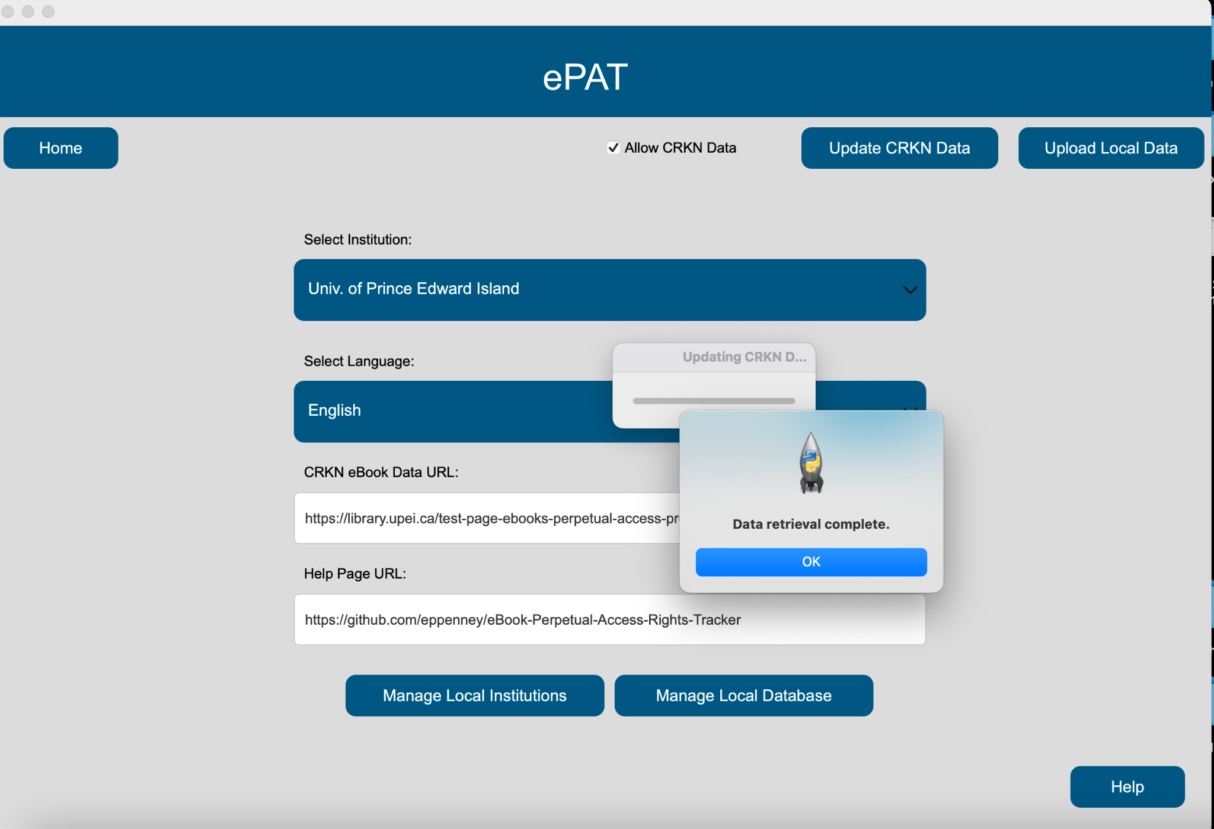

The user can choose to update the database once again in the settings page.



The user can hit the ‘Home’ to return to the Home Page.

**5. Testing**

The system testing process aimed to determine all defects in our project. The program was subjected to a set of test inputs and various observations were made and based on these observations it will be decided whether the program behaves as expected or not. Our Project went through two levels of testing - Unit testing and integration testing for which a separate log has been maintained and linked below.

Testing Log:

[Testing Log](https://docs.google.com/document/d/1eM31tGv0tH1vVN98xRZsTRTXtl2m4NbJvP1FRUw6TKo/edit?usp=sharing)

**6. End User Documentation**

A shorter and simpler documentation is available at the link below for end users in particular. This documentation covers basic operations done throughout the application in the form of a how-to guide.

[End User Documentation](https://docs.google.com/document/d/1B9tGon1OXvCBvJBOfalo51qaheueuNEGSFl19rCmFAg/edit?usp=sharing)

**7. Conclusion**

In conclusion, the development and implementation of the ebook perpetual access tracking application offers a solution to the longstanding challenge faced by librarians in managing perpetual access rights for ebooks. This application streamlines the process and enhances efficiency for librarians from any institution by providing a centralized platform for verifying access rights. With its ability to consolidate separate spreadsheets into a central database, the application simplifies access tracking and ensures accurate and up-to-date information regarding ebook availability. The ebook perpetual access rights tracking application promises to significantly improve the management of ebook collections, and lets librarians spend less time on the task all together.